**1 A) Create a simple sequence-based project.**

**Aim : Add two Numbers**

1. Open UiPath Studio and click on Blank to start a fresh project. Give it a meaningful name. Like Pratical1A.

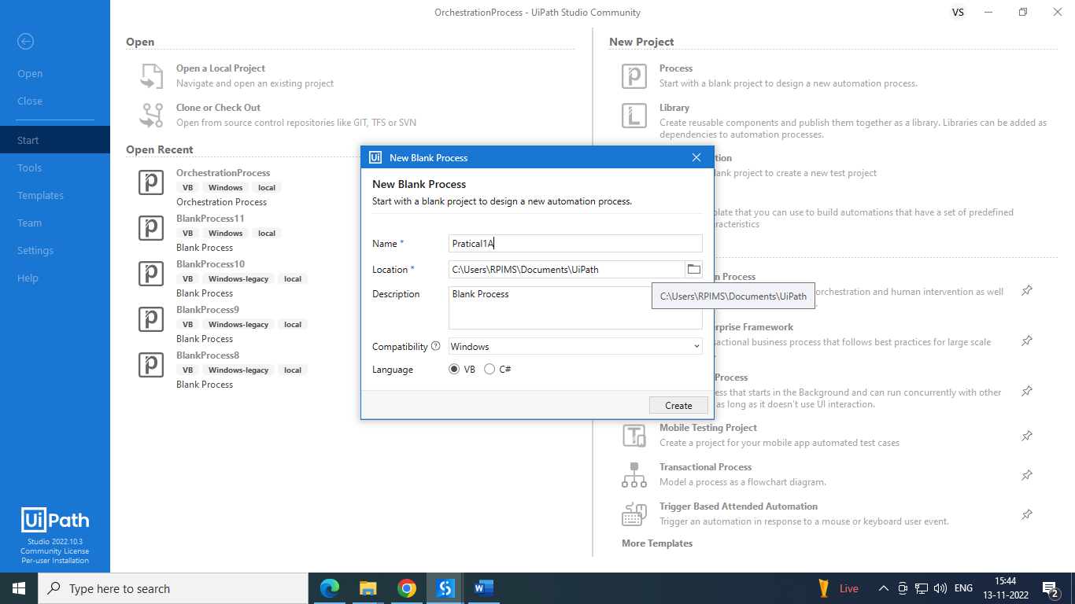

2) Open Main.xaml from Project tab. On the Designer panel, double click a Sequence activity from the Activities panel.

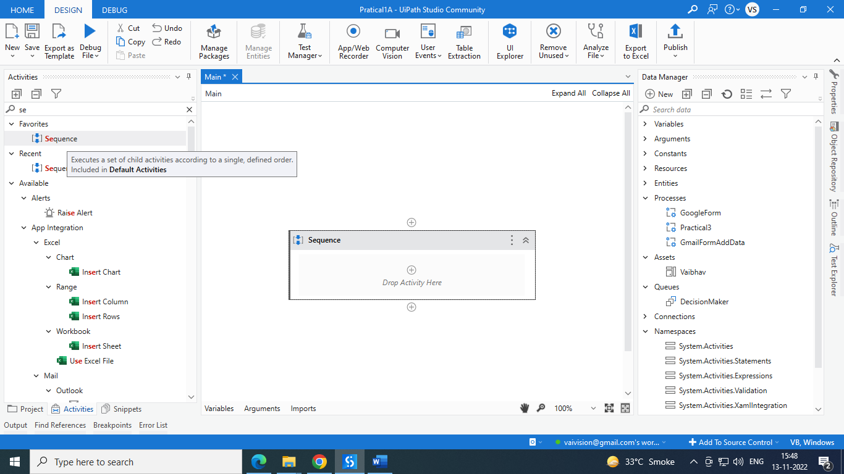

3) Select Variable tab from bottom of page. Create variable x and y and select variable data type as int32 and save.

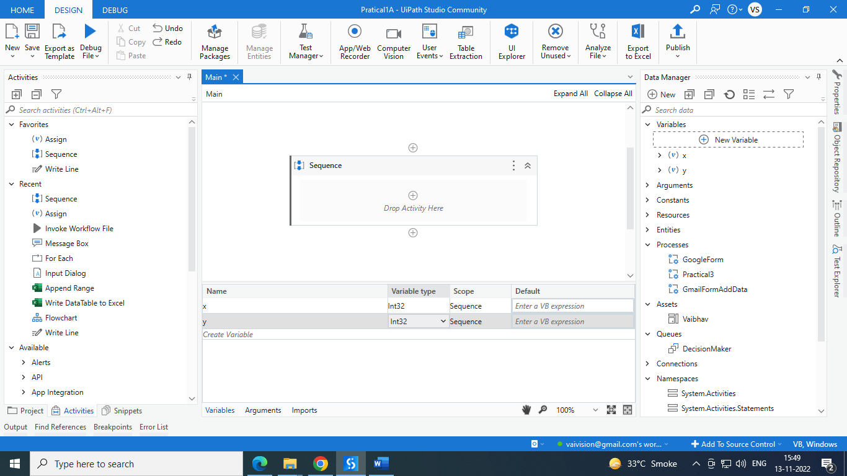  
4) Select and drag input dialog from activities. Fill all data labels. Add entered value x and y variable respectively. As below.

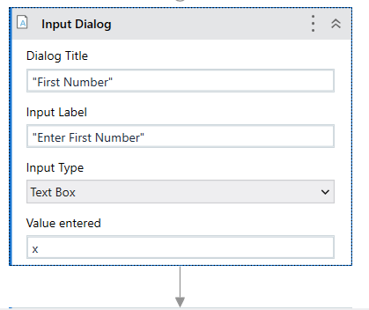

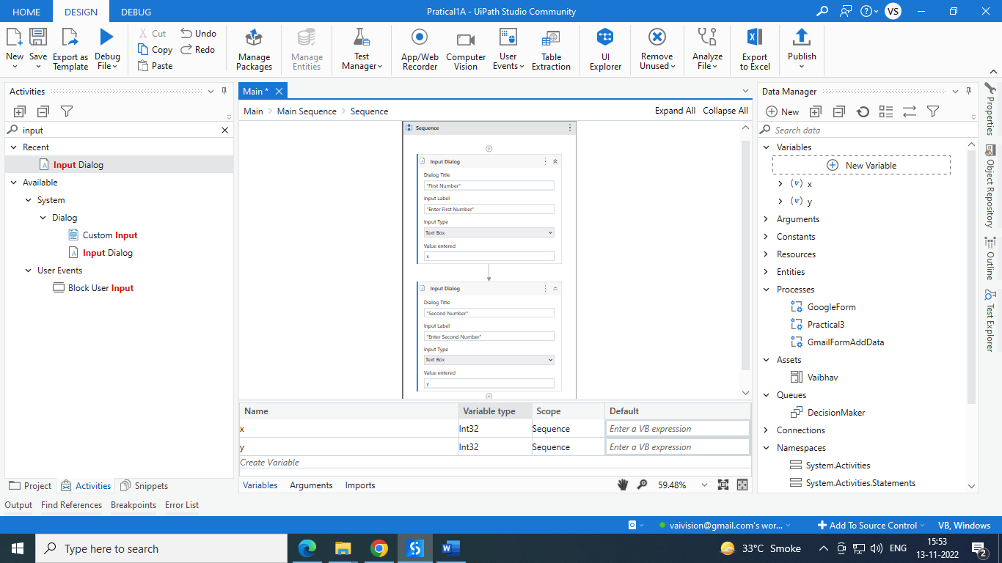

5) select and drag Messagebox from activity menu. Write x+y and save.

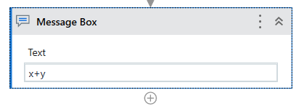

6) Run project and check.

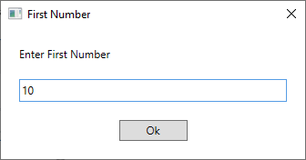

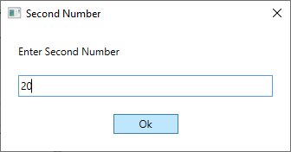

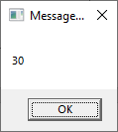

**1.B) Create a simple flowchart-based project.**

**Aim: Create project to show ODD and even using flowchart.**

1. Open UiPath Studio and click on Blank to start a fresh project. Give it a meaningful name. Like Pratical1B.

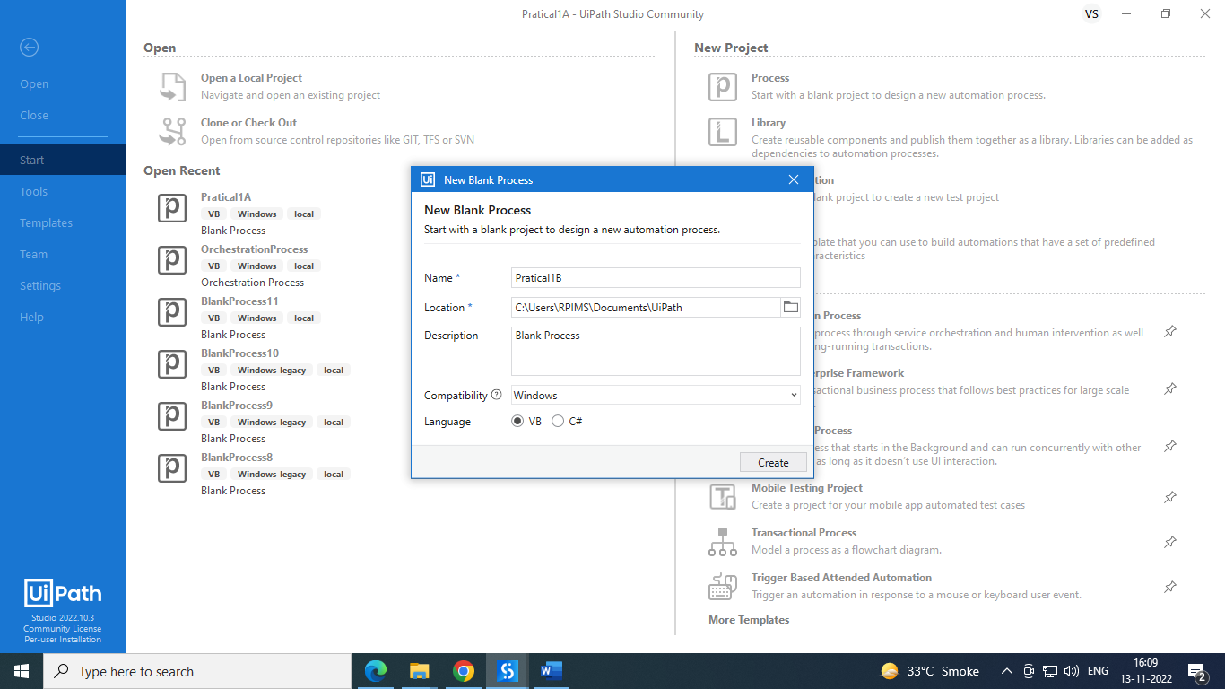

2) Open Main.xaml from Project tab. On the Designer panel, double click a flowchart activity from the Activities panel.

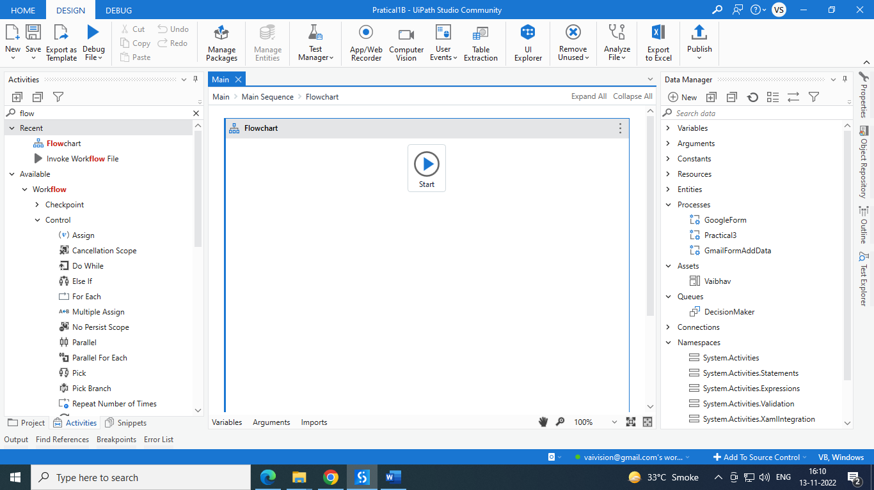

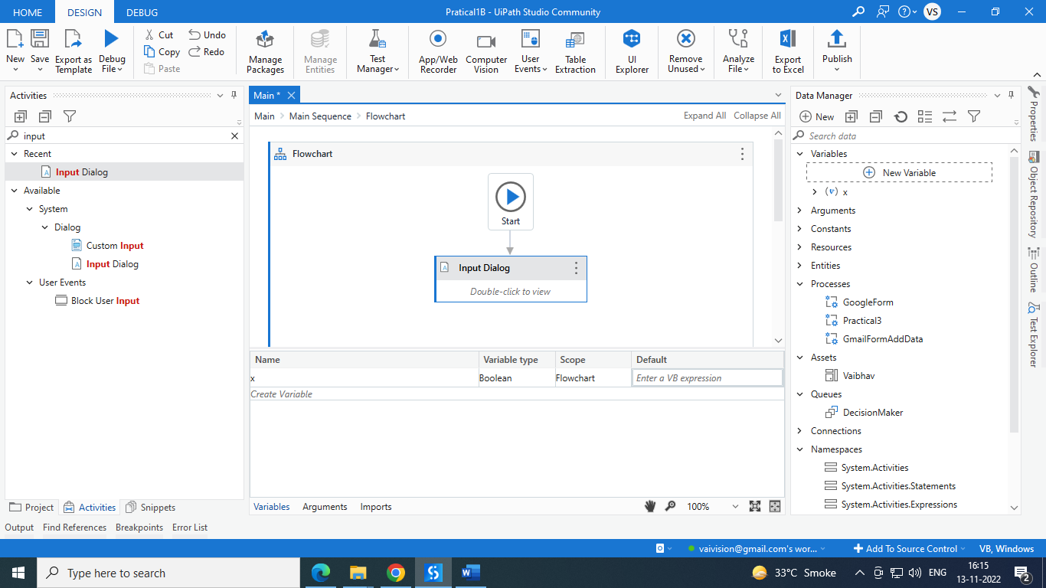

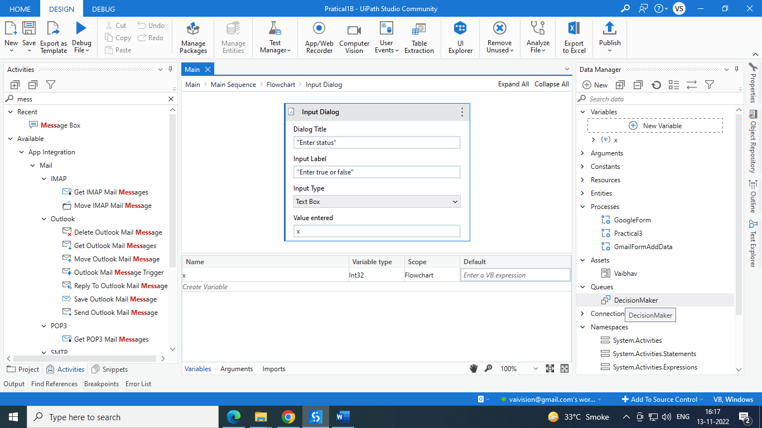

Add next activity flow decision. Set condition like (x mod 2=0) in properties selection.

Add two more message box and connect with true and false flow. And give even number is its true. Give odd number if its false.

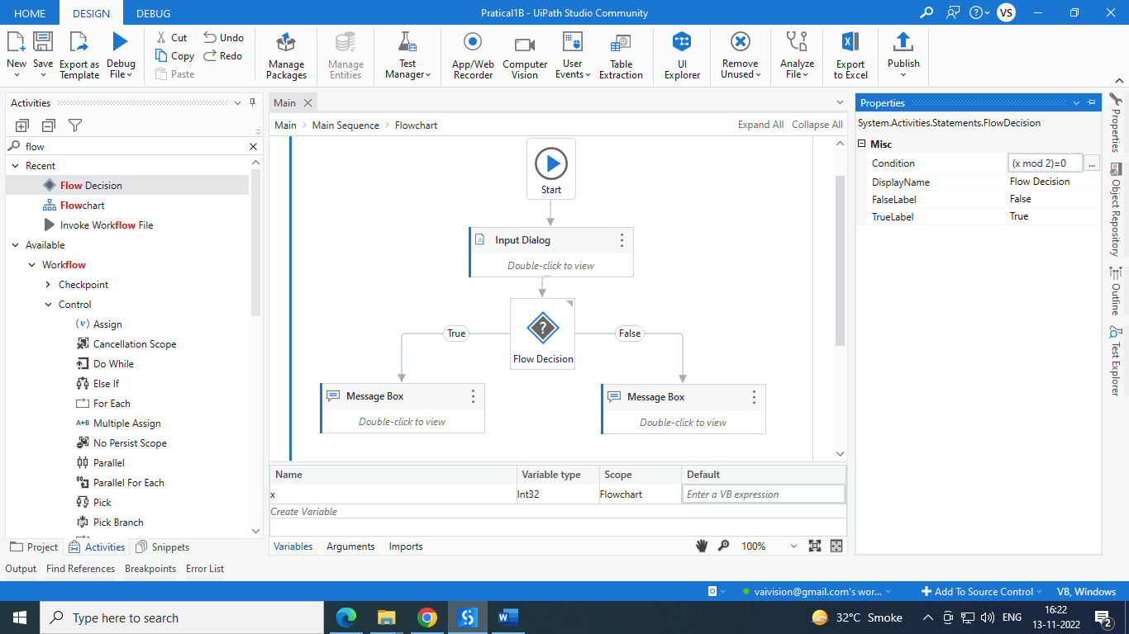

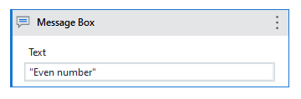

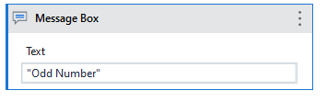

**O/P:**

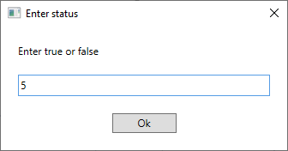

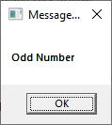

**C. Automate UiPath Number Calculation (Subtraction, Multiplication, Division of numbers).**

Steps: 1. Open UiPath Studio and click on Blank to start a fresh project. Give it a meaningful name

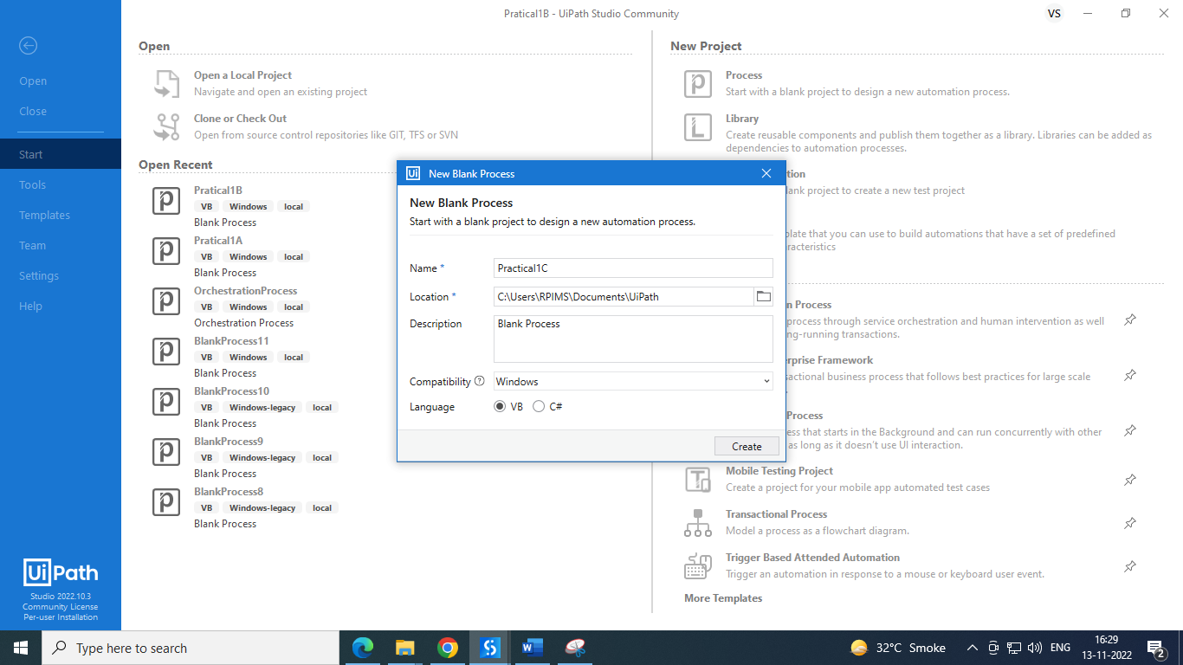

Add sequence on page then Select 2 input dialog for two number from activity panel and create variable x and y with int32 datatype.

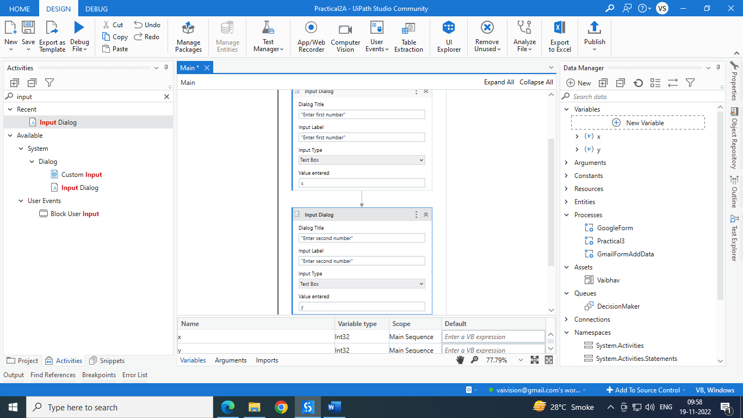

Select another Input dialog for selecting operation like addition, subtraction, division and multiplication, which data stored in Z variable which is string datatype.

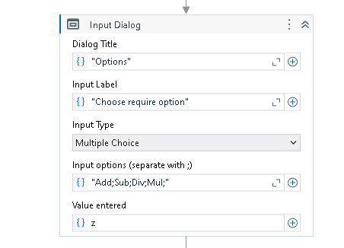

Select **if** activity from activity window, then add 1 message box from activity for addition.

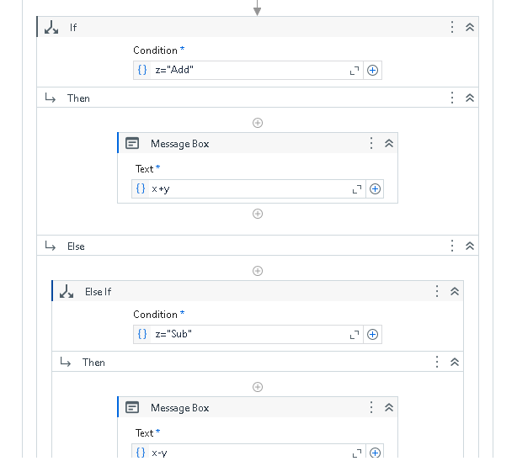

And add subtraction, division and multiplication in **Else-if** activity.

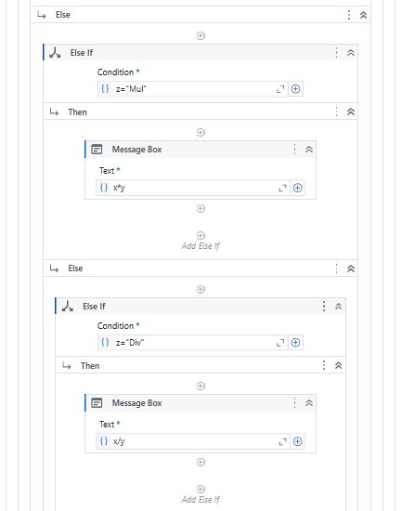

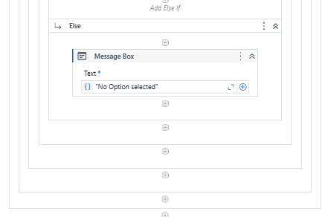

O/p:

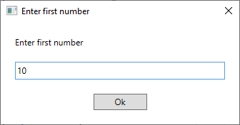 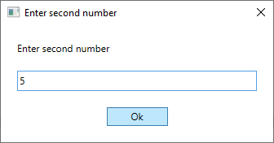

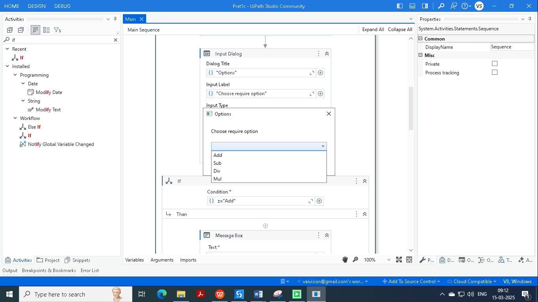

When we choose addition then it will show below message box.

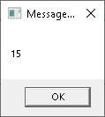

**d. Create an automation UiPath project using different types of variables (number, datetime, Boolean, generic, array, data table).**

**Steps:**

Follow steps as above to create project. Also give appropriate name.Create variable as below.

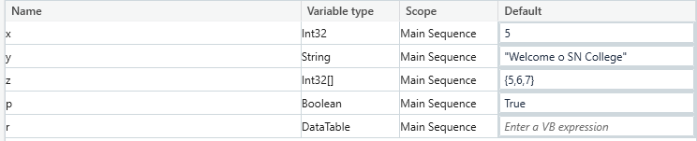

Create data table from Build Data table. As per blow screenshot.

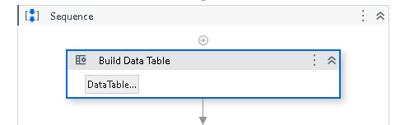

Click on data table and create data like

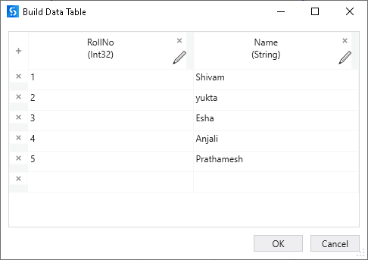

Also add message box to show Integer and string data.

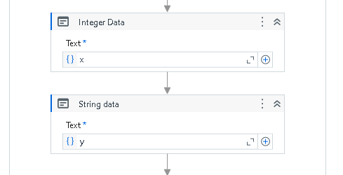

Add for each activity for Integer array to display array data.

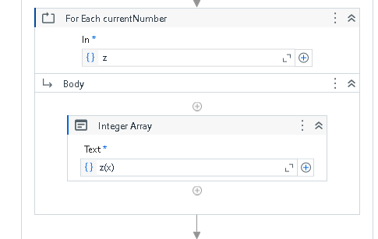

For Boolean data add message box out side of for each.

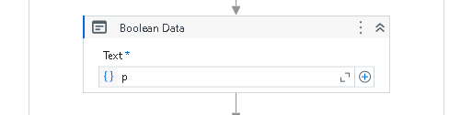

Add for each table to fetch data from data table. Instead of CurrentRow(0) write CurrentRow.Item(0).ToString & CurrentRow.Item(1).ToString.

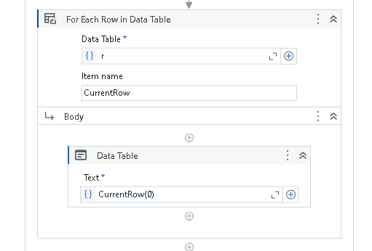

**O/p:**

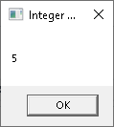 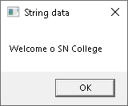

Integer Array:

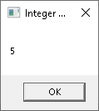 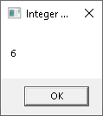 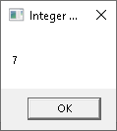

Boolean Data:

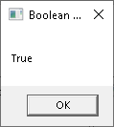

Datatable Data:

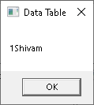 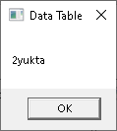 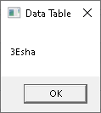 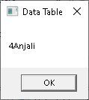 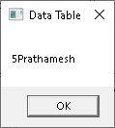

**Practical 2 : Decision making and looping**

1. Consider an array of names. We have to find out how many of them start with the letter "a". Create an automation where the number of names starting with "a" is counted and the result is displayed.

Step 1: Open UI path and create new project with appropriate name and choose language type VB.

Step 2: Add sequence in project from activity panel. Create variable “names”. Variable type Array of [T] String.

Default values {"vijay","ajay","rahul","ashish","arman","akash","vipul"}.

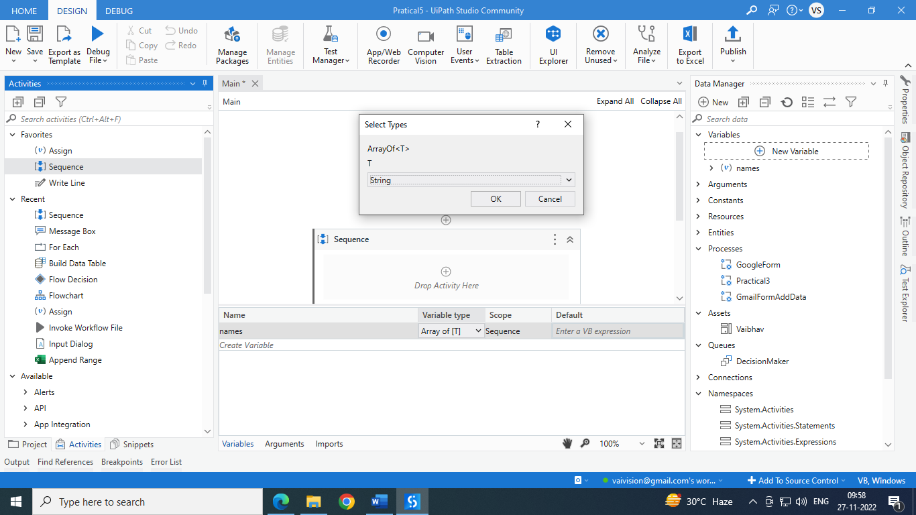

Add “for each” from activities panel. In = names

Add if inside “for each”. Add condition like currentItem.ToString.StartsWith("a").

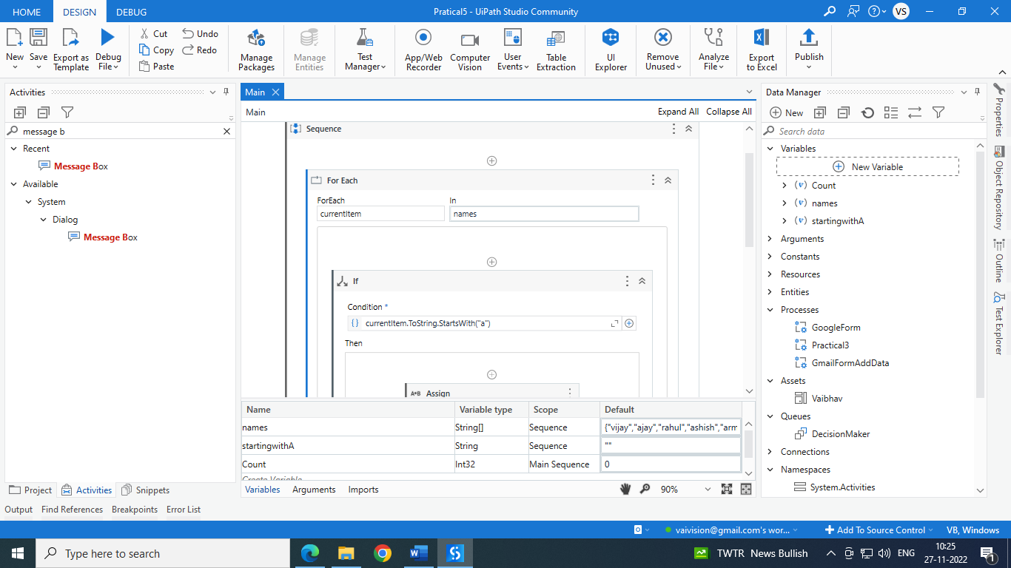

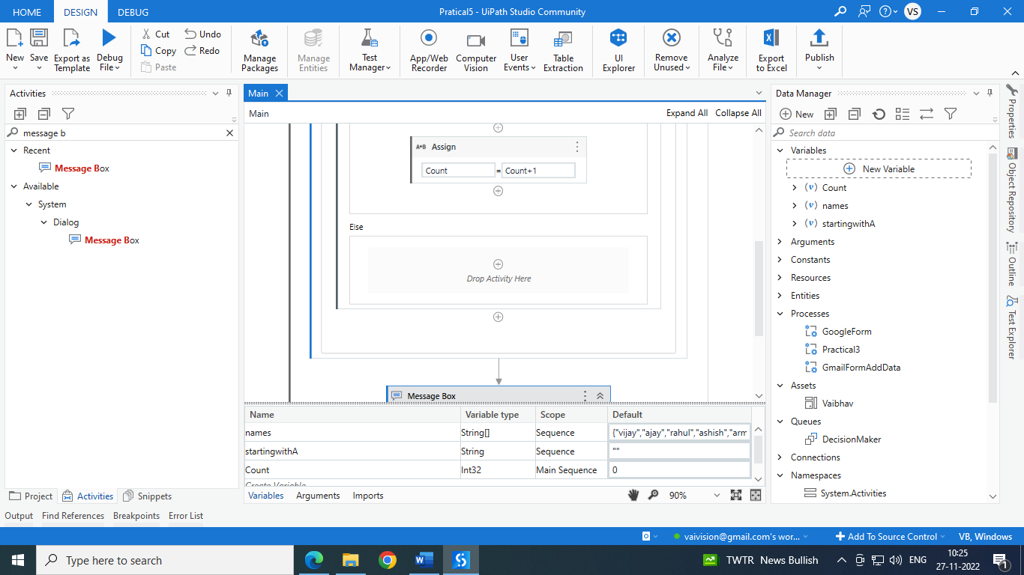

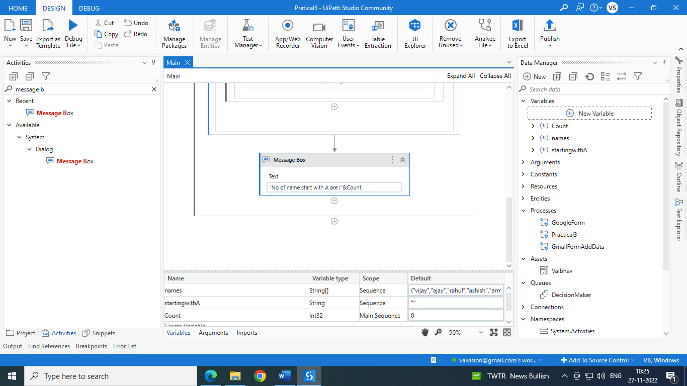

o/p:

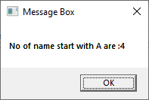

**2b. Demonstrate switch statement with an example.**

Step 1: Open UI path and create new project with appropriate name and choose language type VB.

Step2: Select Classic Input dialogbox from the activity window and drop into sequence also fill below details.

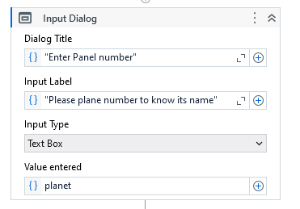

Create planet as a variable as below.

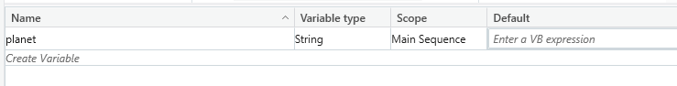

Step 3: Select switch activity from activity window and drop into sequence and add cases according to below text input. Choose message box activity to display message.

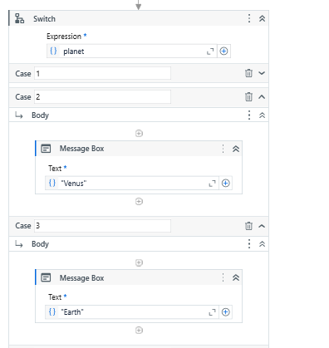

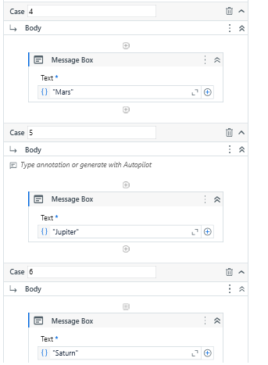

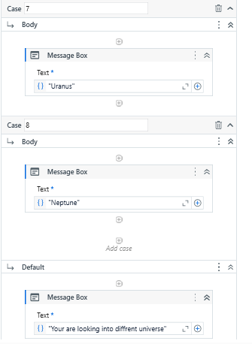

**O/P :**

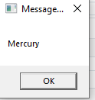 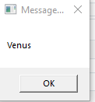 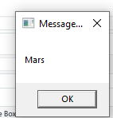

**2c.Create an automation To Print numbers from 1 to 10 with break after the writeline activity inside for each activity**

Step 1: Open UI path and create new project with appropriate name and choose language type VB.

Create variable x and give value as below.

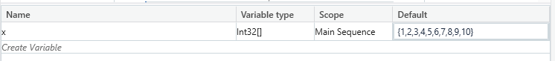

Step 2: Select For each activity from the activity window and drop into sequence also fill below details.

Step 3: Select write Line activity from the activity window and drop into sequence and give “size of integer array” as text input.

Step 4 : Select Break activity from the activity window and drop into sequence to break the loop.

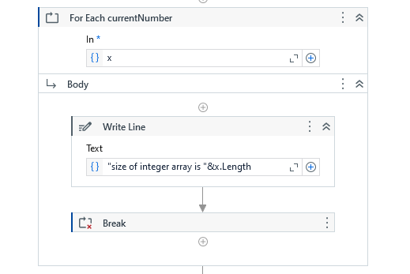

Step 5 : Select Write Line activity from the activity window and drop into sequence to display output as string.

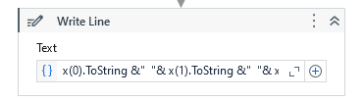

**O/P :**

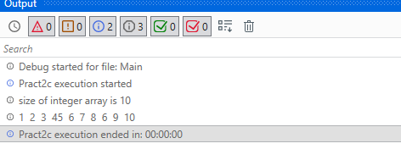

**2d. Create an automation using Do..While Activity to print numbers from 5 to 1.**

Step 1: Open UI path and create new project with appropriate name and choose language type VB.

Create variable x and give value as below.

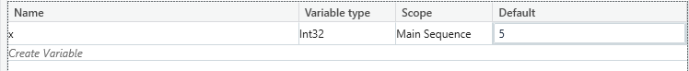

Step 2: Select Do While activity from the activity window and drop into sequence also fill below details. Select message box activity and give x variable as input.

Step 3 : Select Assign activity from the activity window and drop into sequence and give value to save as

x-1 with condition that that x > 0.

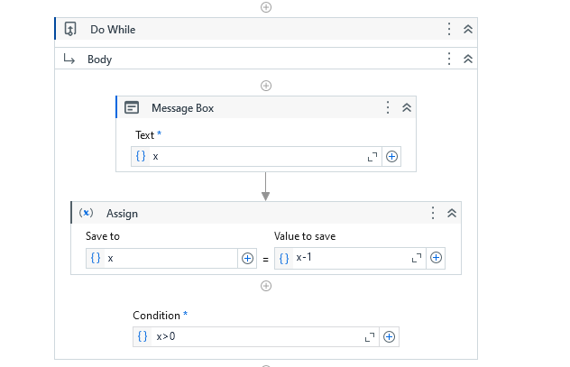

**O\P:**

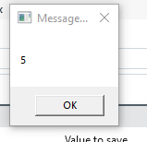 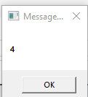 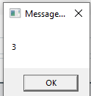 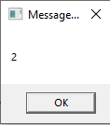 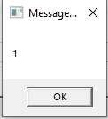

**2e.Create an automation using Delay Activity between two writeline activities to separate their execution by 5 seconds.**

Step 1: Open UI path and create new project with appropriate name and choose language type VB.

Create variable x and give value as below.



Step 2: Select Do While activity from the activity window and drop into sequence also fill below details. Select message box activity and give x variable as input.

Step 3 Select Delay activity from the activity window and drop into sequence to delay the output message by 5 seconds.

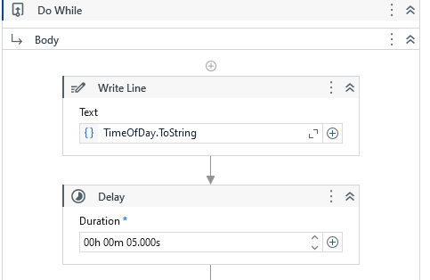

Step 4 : Select Assign activity from the activity window and drop into sequence and give value to save as

x-1 with condition that that x > 0.

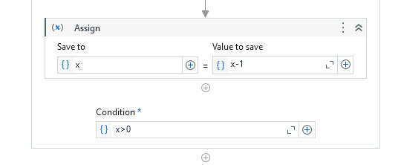

**O\P:** The output will be displayed with 5 seconds of delay.

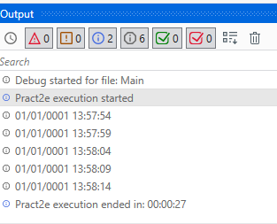

**2f. Create an automation to demonstrate use of decision statements (if).**

Step 1: Open UI path and create new project with appropriate name and choose language type VB.

Create variable x and give value as below.

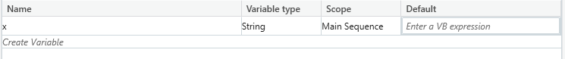

Step 2 : Select Input Dialog activity from the activity window and drop into sequence. Give Dialog Tittle, Input Label, Input Type as below and enter value as variable x.

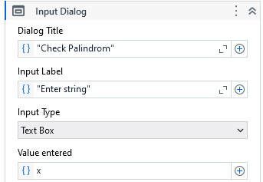

Step 3 : Select If activity from the activity window and drop into sequence to give a condition.

If x is equal to reverse of string of x then the message box will display output as : “Entered String is Palindrome.”

Else it will display : “ Entered string is not palindrome”.

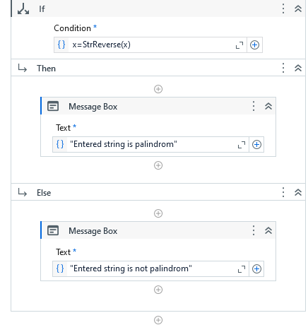

**O/P :**

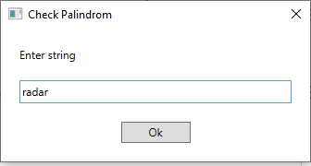 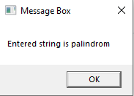

**Practical 3: Types of Recording:.**

**Aim : Add two Numbers**

**3.A. Automate any process using basic recording**

Step 1: Open UI path and create new project with appropriate name and choose language type VB.

Step 2: Open notepad

Step 3: Click on App/Web recorder

Step 4: Click on notepad. Select white area and type anything. And save process.

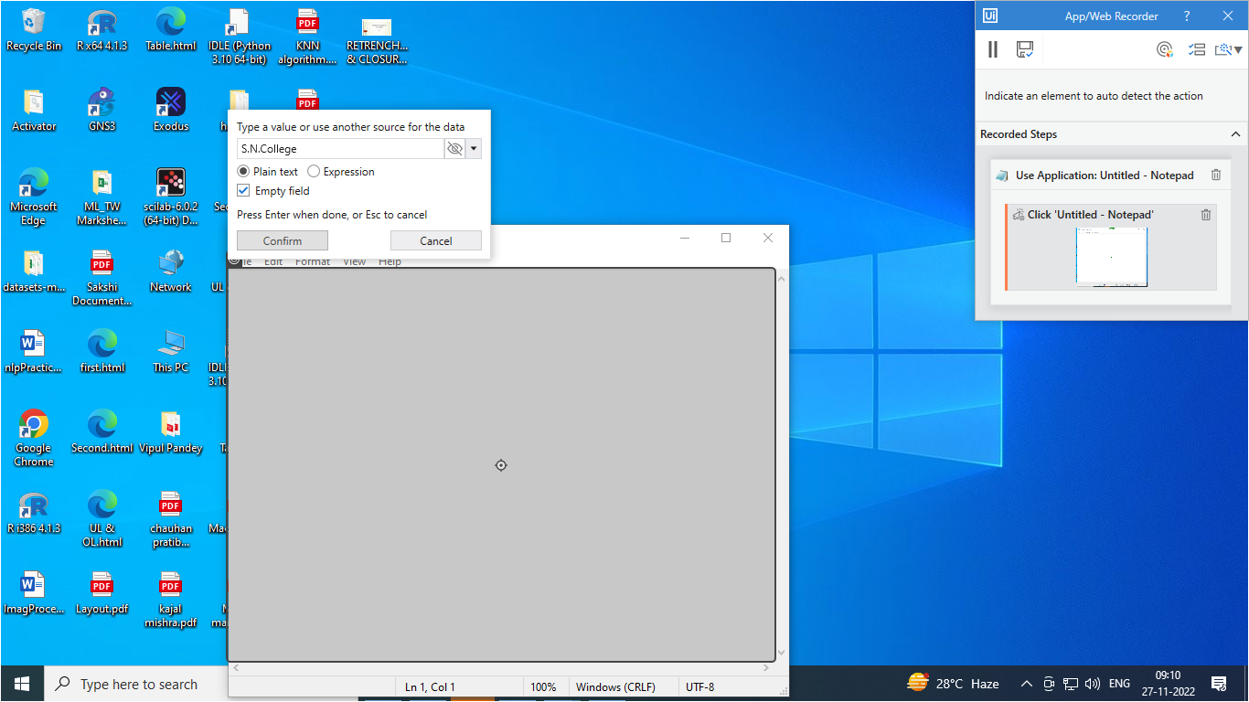

After saving it will create below structure automatically.

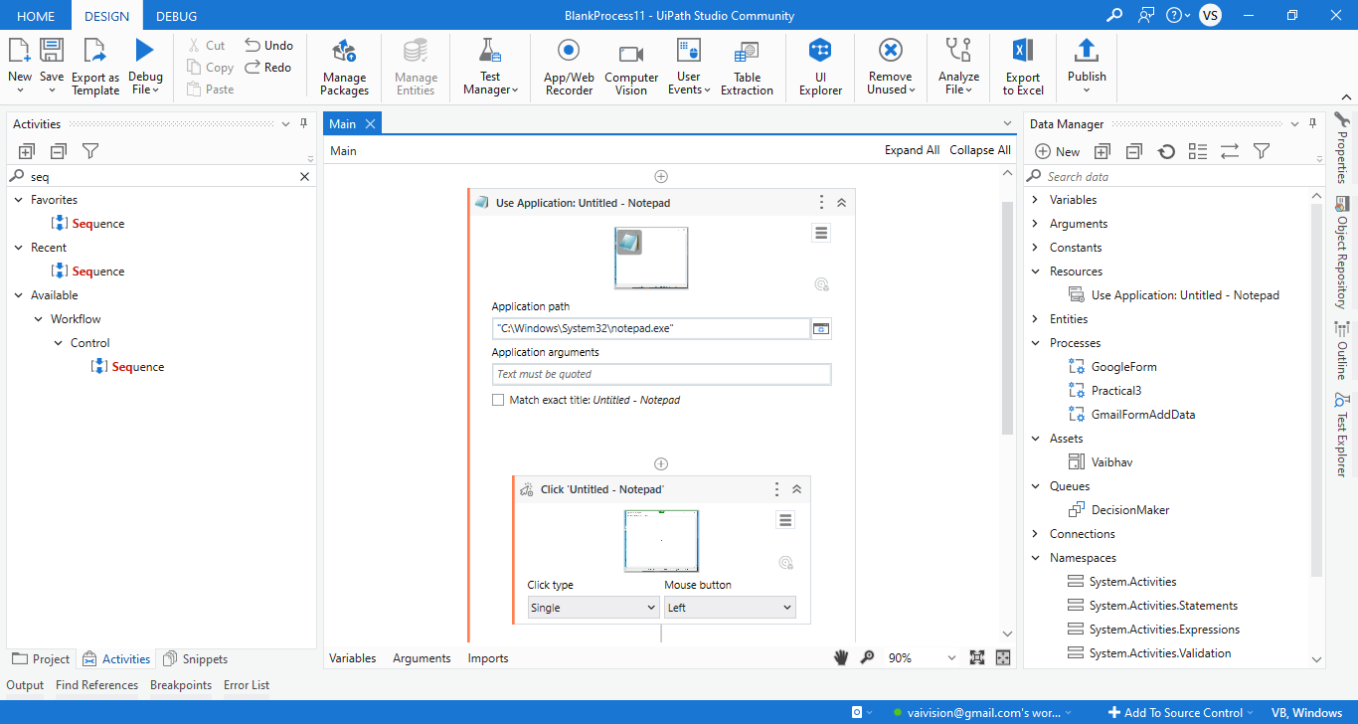

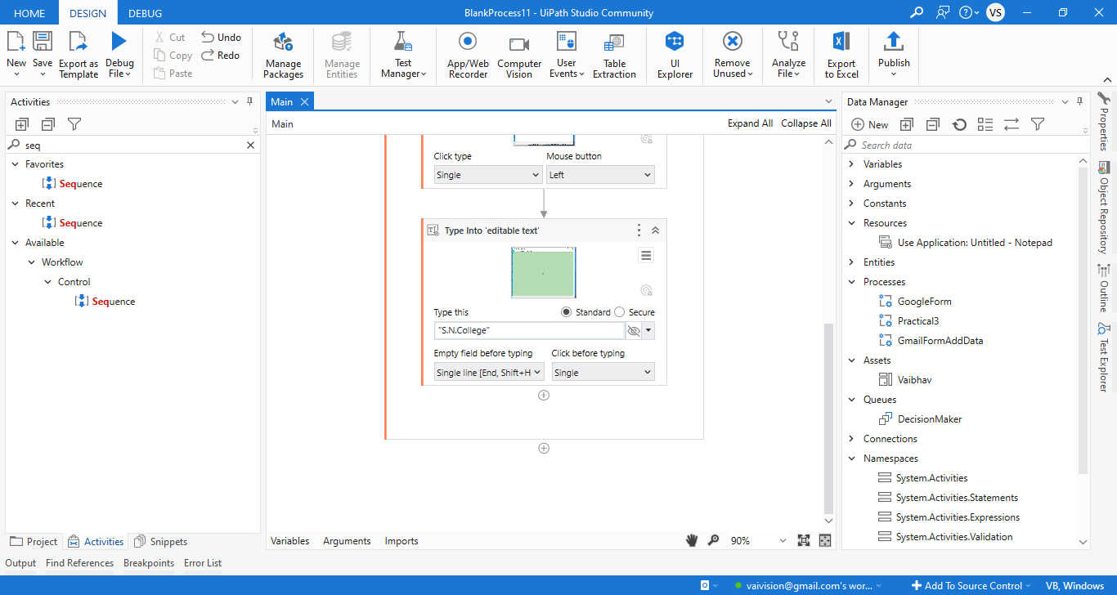

**O/P:**

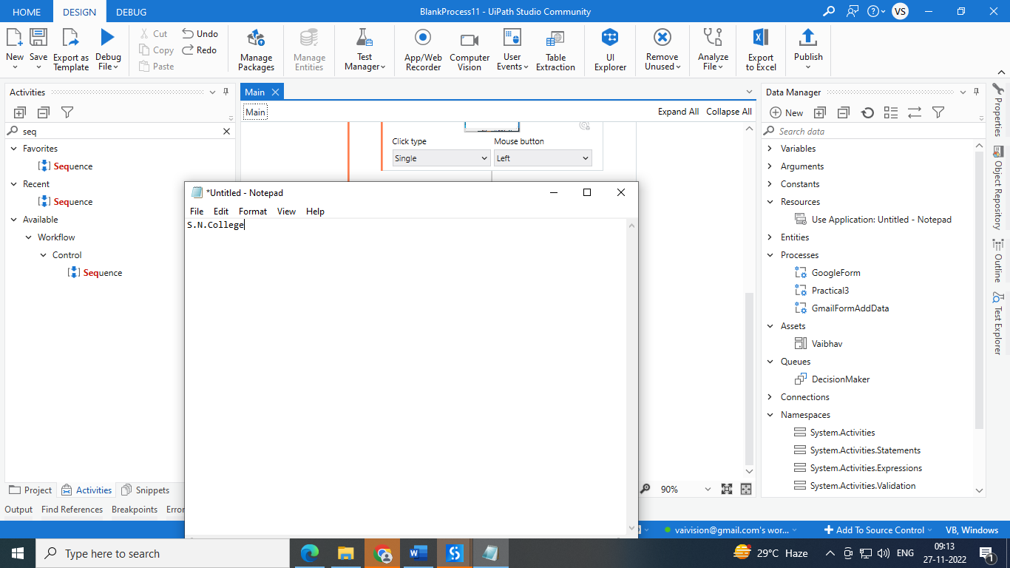

**B: Basic Recording using Notepad**

Step 1: Open UI path and create new project with appropriate name and choose language type VB.

Step 2: Click on App/Web recorder

Step 3: Click on search of windows. Select require application. Here I am selecting notepad.

Step 4: Then I select blank page of notepad and type into it.

Step 5: Then I click on File menu.

Step 6: Click on save and type file name.

Step 7: Click on save button.

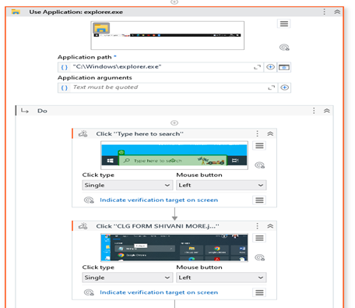

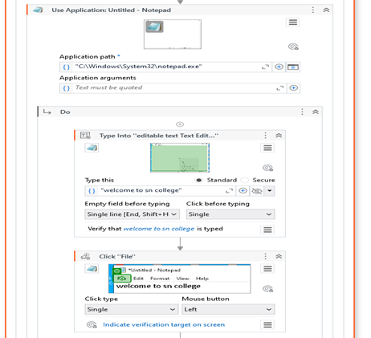

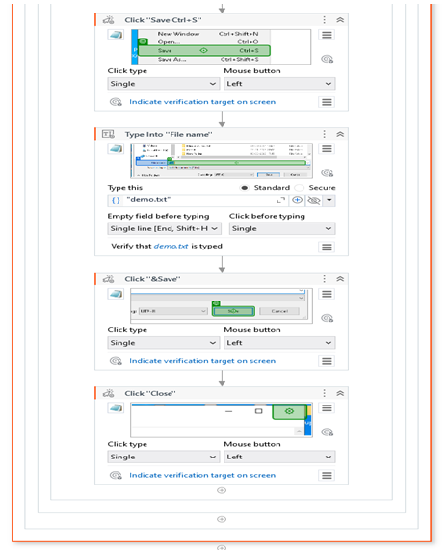

**O/P:**

**After running process Cursor will click on search of windows. Select require application. Here I am selecting notepad. Then I select blank page of notepad and type into it. Then I click on File menu. Click on save and type file name. Then click on save button.**

**3.C) Automate any process using desktop recording using Tool bar.**

Step 1: Open UI path and create new project with appropriate name and choose language type VB.

Step 2: Open notepad

Step 3: Click on App/Web recorder

Step 4: Click on notepad. Select white area and type anything. And save process.



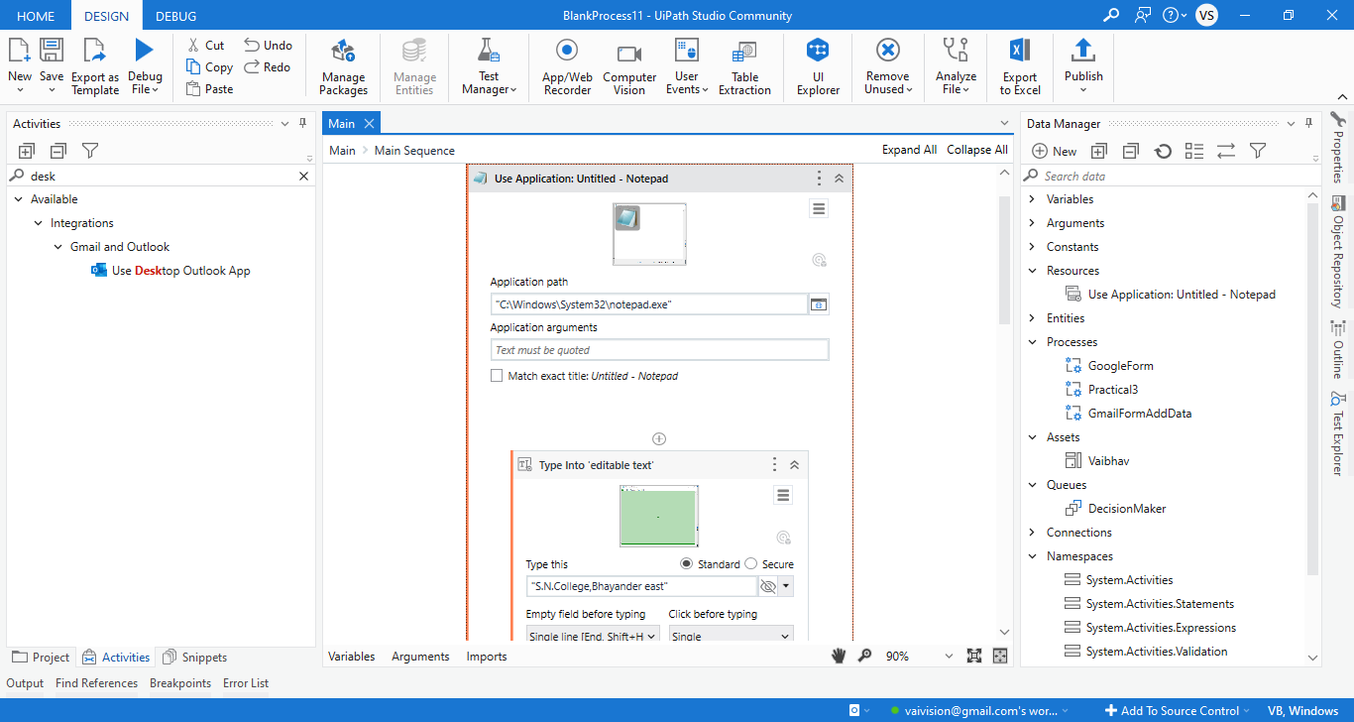

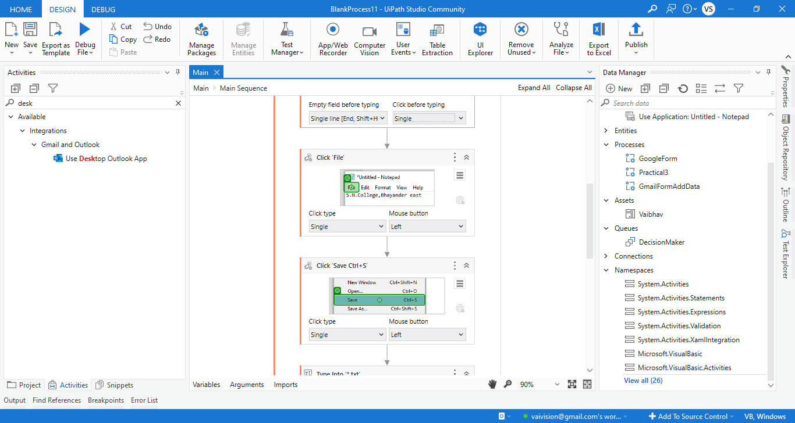

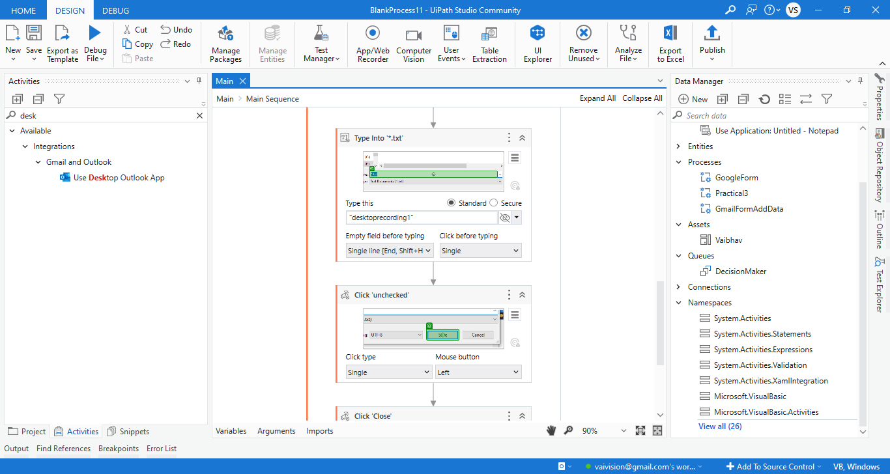

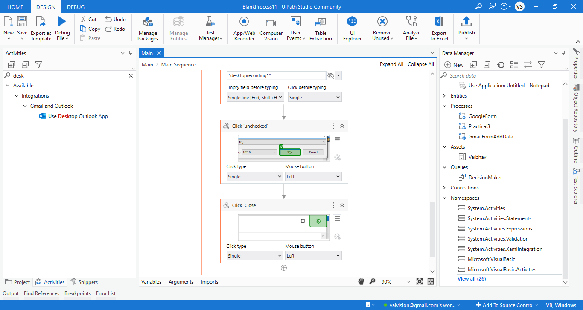

Step 5: Close the notepad.

O/P : Also automatically save with desktoprecording1.txt

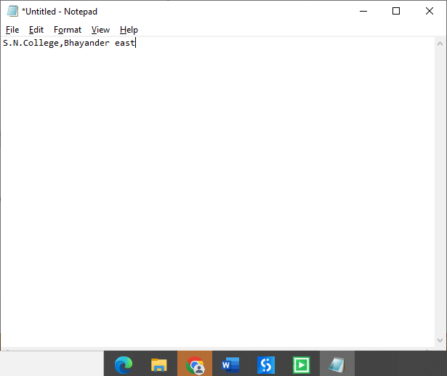

**3 e) Web Recording e.g. Find the rating of the movie from imdb web site**

Step 1: Open UI path and create new project with appropriate name and choose language type VB.

Step 2: Click on App/Web recorder. Choose chrome and click on it.

Step 3: It will open chrome. Select address bar and type any movie name with imdb rating. Press enter key.

Step 4: It will show Imdb rating of movie.

Step 5: Click on save recording.

Step 6: It will show all process like below.

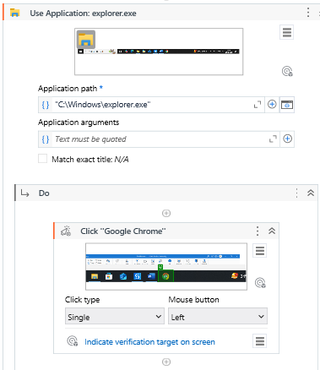

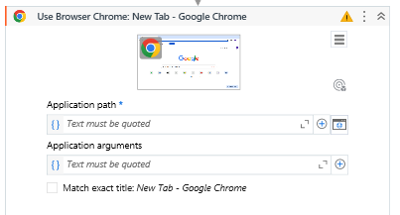

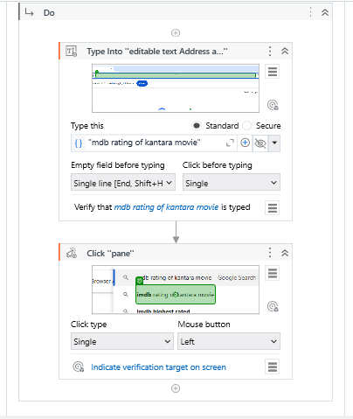

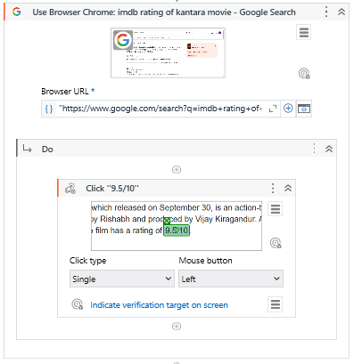

**O/P: Run your bot and check. It will show same output.**

**3 f) Automate any process using web recording**

Step 1: Open UI path and create new project with appropriate name and choose language type VB.

Step 2: Click and drag open browser from the activity panel.

Step 3: Enter Url of the form under double quotation.

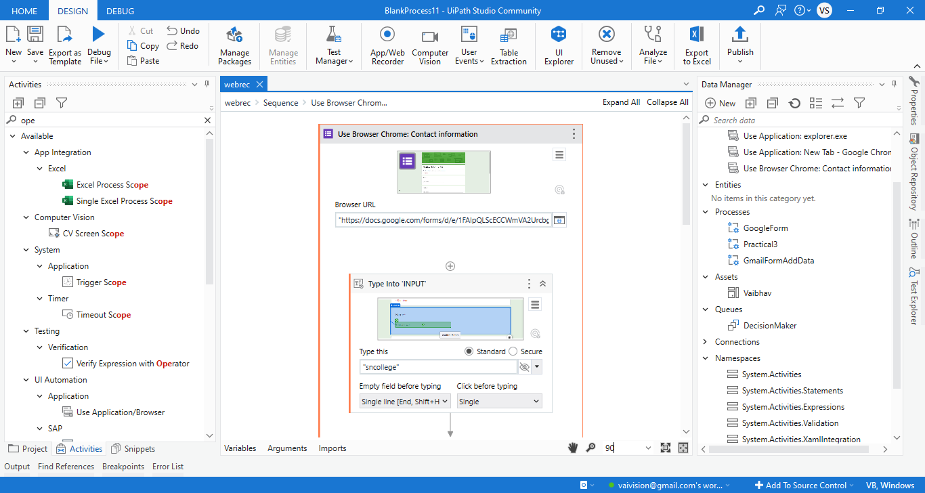

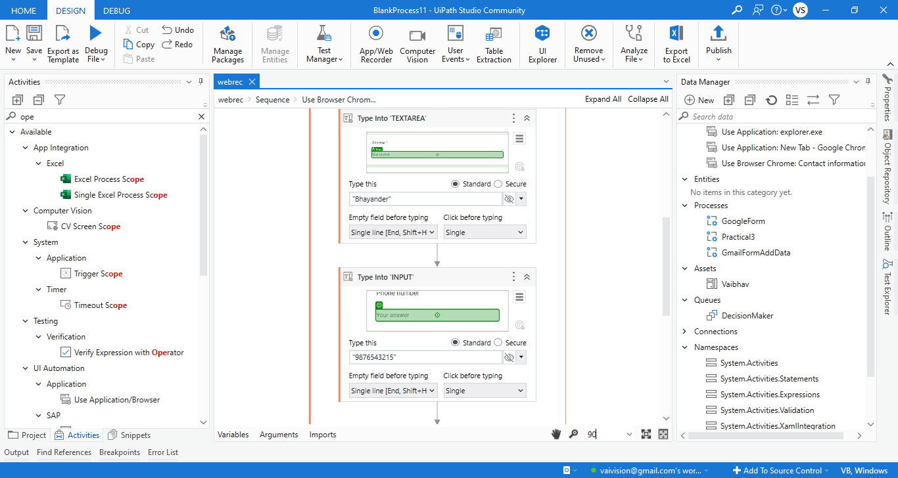

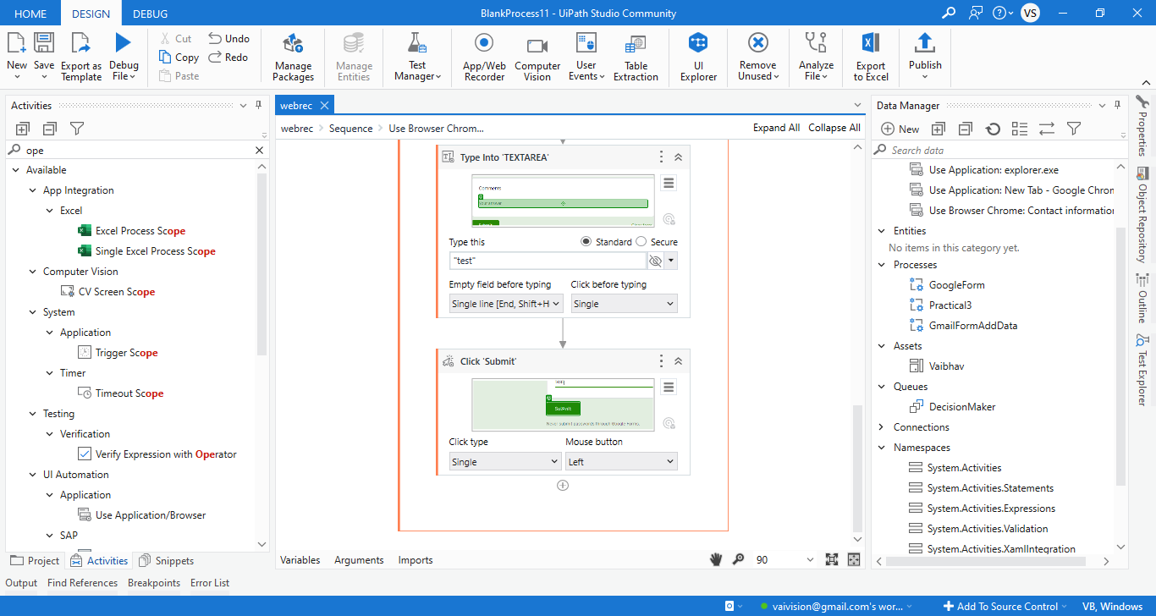

O/P:

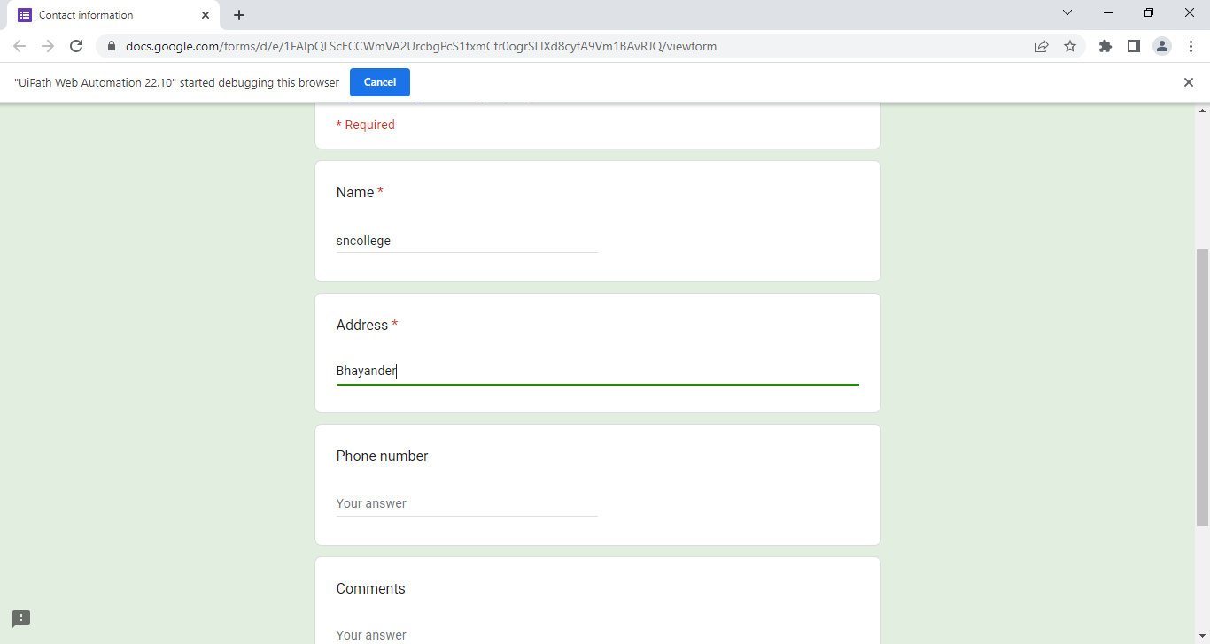

**Practical4:Excel Automation**

**4a. Automate the process to extract data from an excel file into a data table and vice versa.**

Step 1 : Create an excel file with name StudentDetails.xlsx with following data.

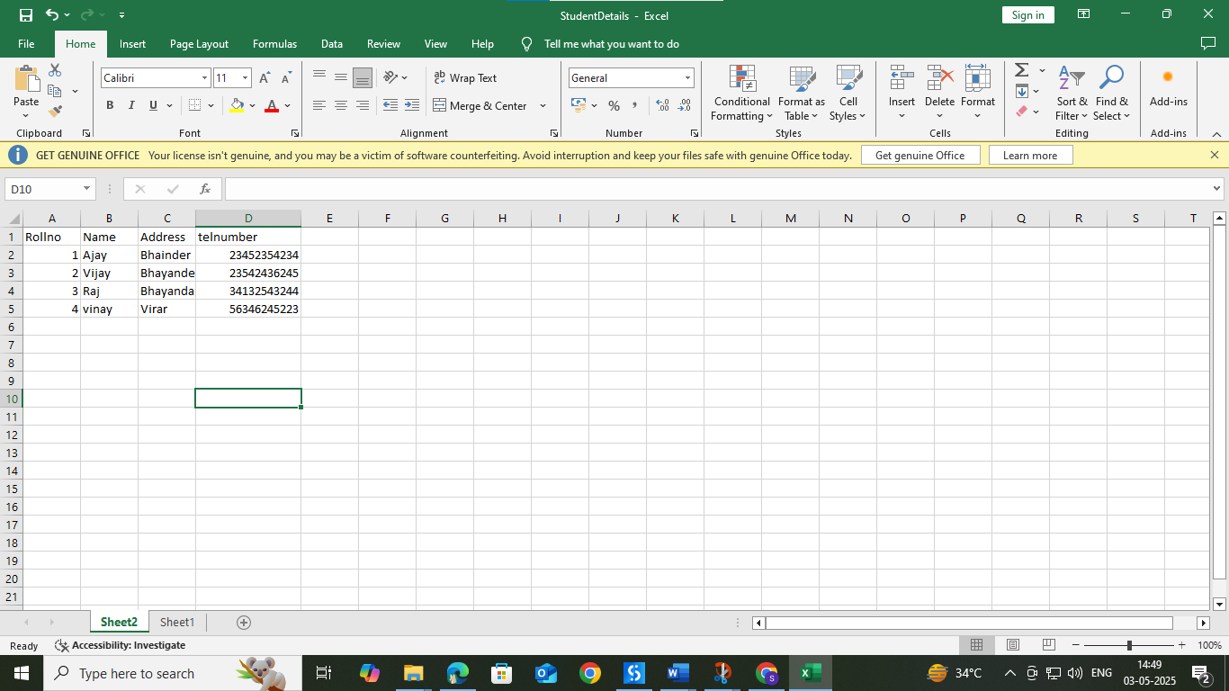

Step 2: Open UI path and create new project with appropriate name and choose language type VB.

Step 3 : Select Excel Application Scope from the activity window and drop into sequence and insert the path of the StudentDetails.xlsx file.

Step 4 : : Select Do activity from the activity window and drop into sequence and then select Read Range from the activity window and give “sheet1” as read range input.

Step 5 : Select For Each Row in Data Table activity from the activity window and drop into sequence and give inputs as shown below.

Step 6 : Select Write Range activity from the activity window and drop into sequence to specify the sheet where we need to copy the data and give inputs as shown below. Here sheet2 is given as input for the data to be copied from sheet1.

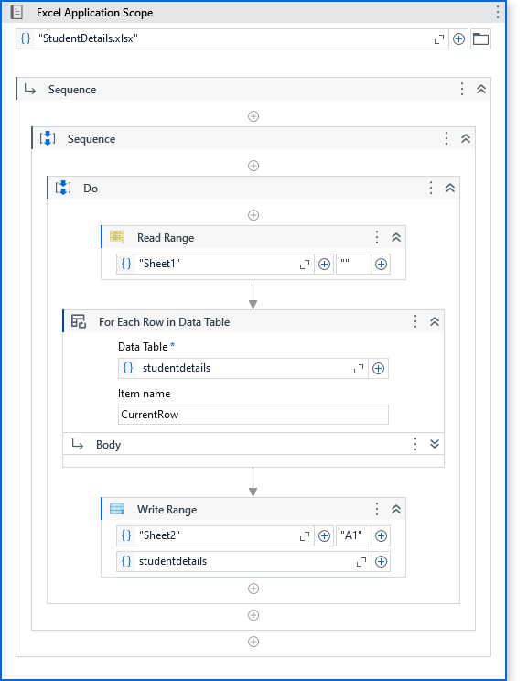

**O/P :**

Here data from Sheet2 is copied to Sheet1

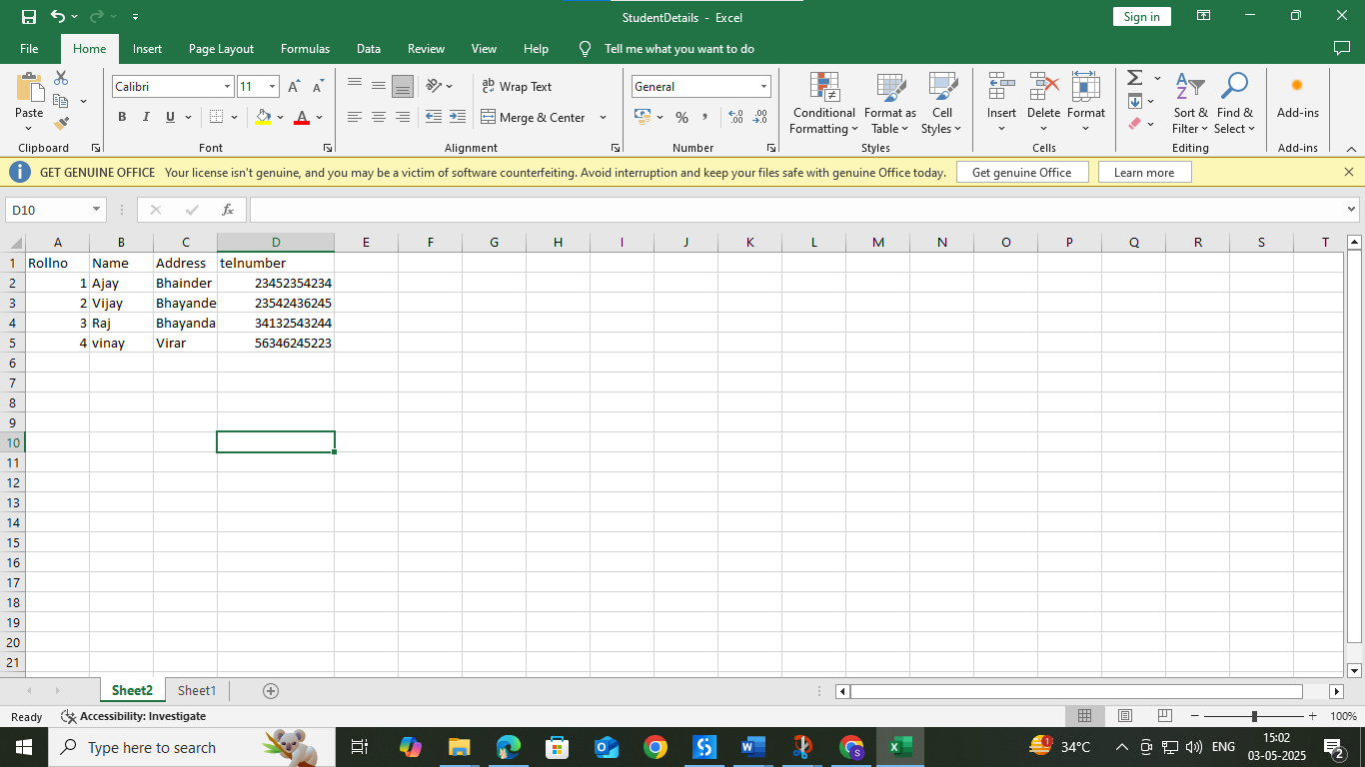

**4b. Create an automation to Write data to specific cell of an excel sheet.**

Step 1 : Create an empty excel file StudentDetails.xlsx.

Step 2 : Step 2: Open UI path and create new project with appropriate name and choose language type VB.

Step 3 : Select Excel Process Scope from the activity window and drop into sequence

Step 4 : Select Do activity from the activity window and then select Use Excel File activity and give inputs as below. Insert StudentDetails.xlsx as excel input.

Step 5 : Again select Do activity from the activity box and insert write cell activity to specify the data to be written in specific cell and give input as below along with the cell location

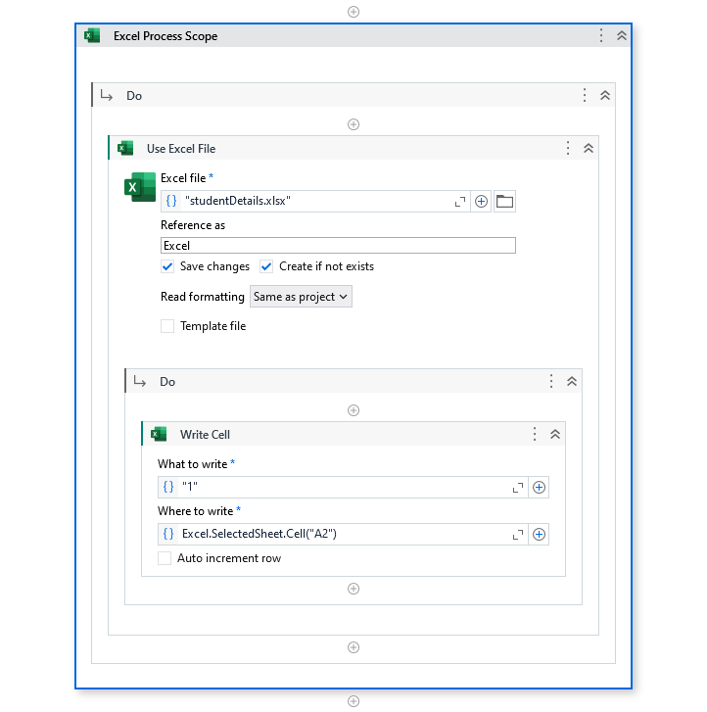

**O/P :**

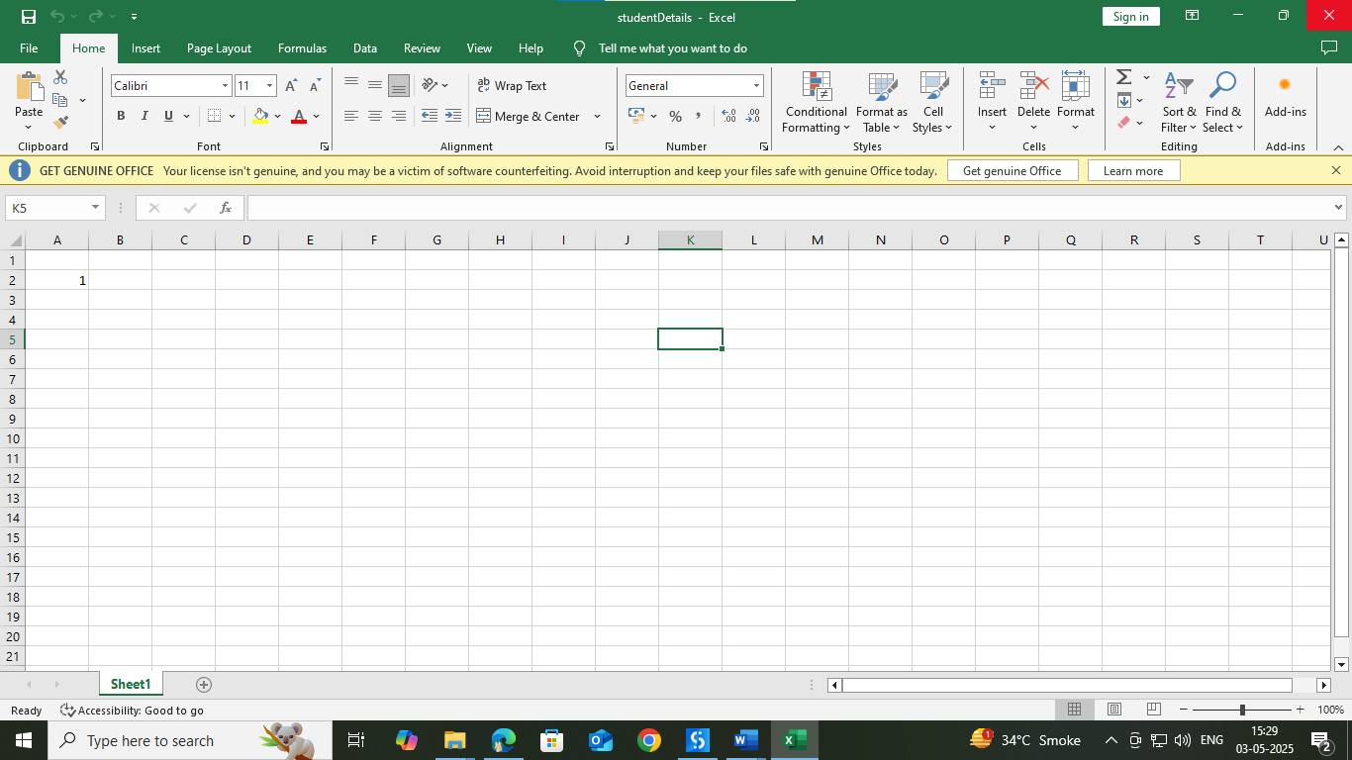

**4c. Create an automation to Read data to specific cell of an excel sheet.**

Step 1 : Create an excel file with name StudentDetails.xlsx with following data.

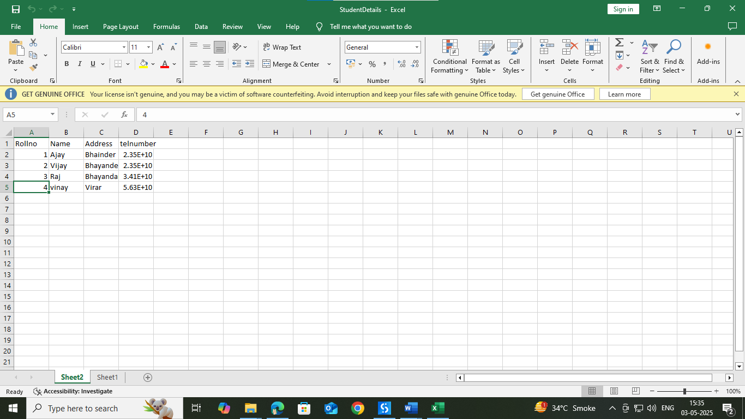

Step 2 : Step 2: Open UI path and create new project with appropriate name and choose language type VB.

Step 3 : Select Excel Process Scope from the activity window and drop into sequence

Step 4 : Select Do activity from the activity window and then select Use Excel File activity and give inputs as below. Insert StudentDetails.xlsx as excel input.

Step 5 : Again select Do activity from the activity box and insert read cell activity to read the data from the specified location. Use input values as shown below to read the data

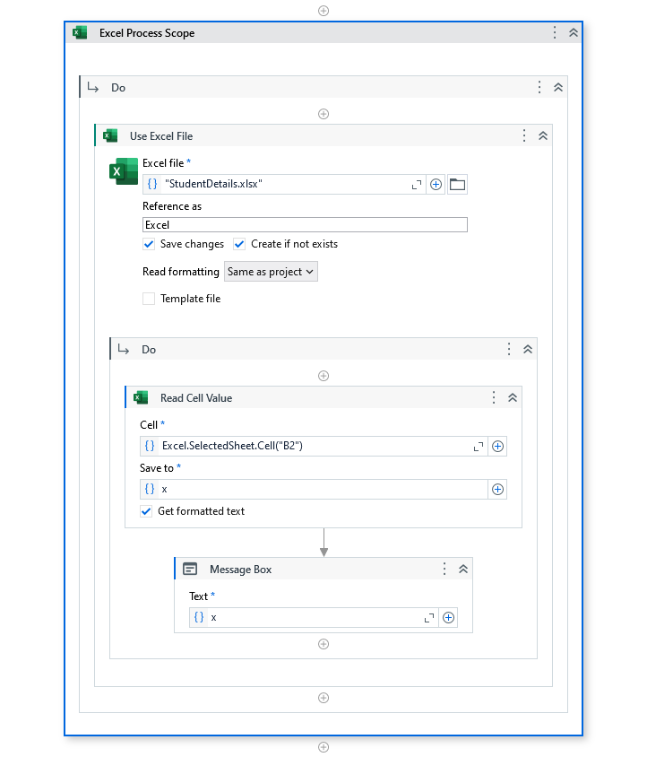

**O/P :**

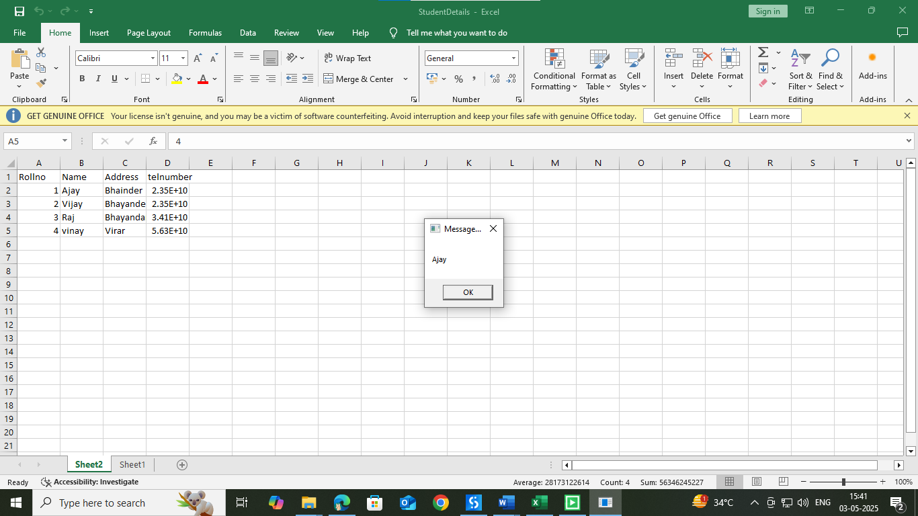

**4d. Create an automation to append data to specific cell of an excel sheet.**

Step 1 : Create an empty excel file StudentDetails.xlsx.

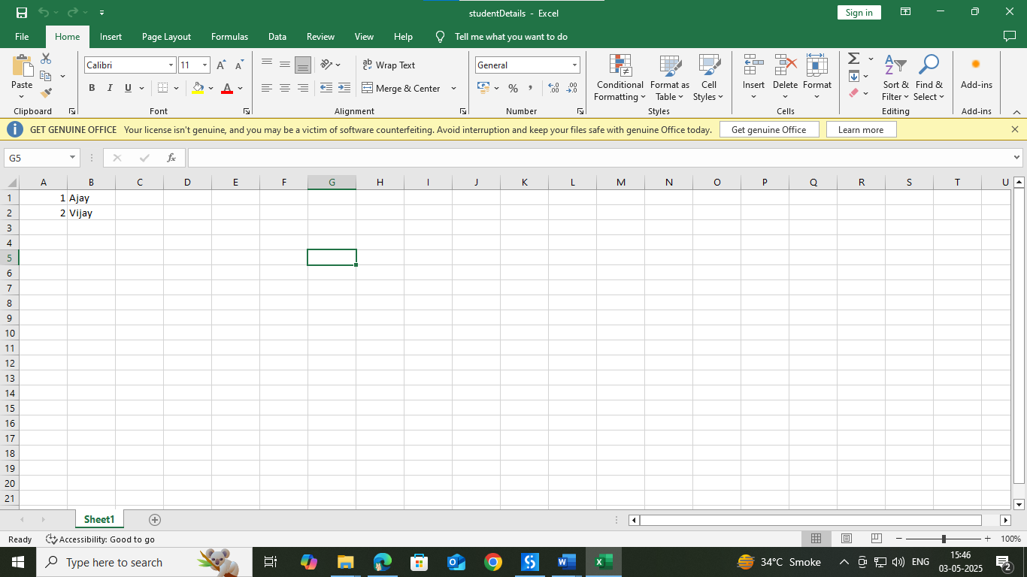

Step 2 : Step 2: Open UI path and create new project with appropriate name and choose language type VB.

Step 3 : Select Excel Process Scope from the activity window and drop into sequence

Step 4 : Select Do activity from the activity window and then select Use Excel File activity and give inputs as below. Insert StudentDetails.xlsx as excel input.

Step 5 : Again select Do activity from the activity box and insert Build data table and then insert append range . Use input values as shown below to read the data

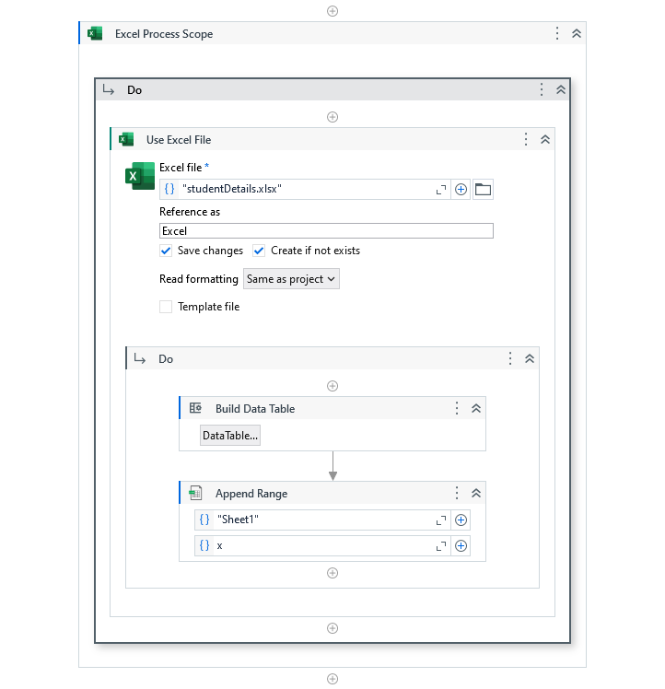

**o/p:**

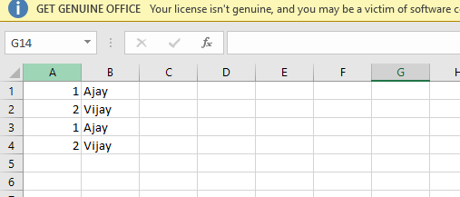

**4e. Create an automation to sort a table of an excel sheet.**

Step 1 : Create an excel file Student.xlsx.

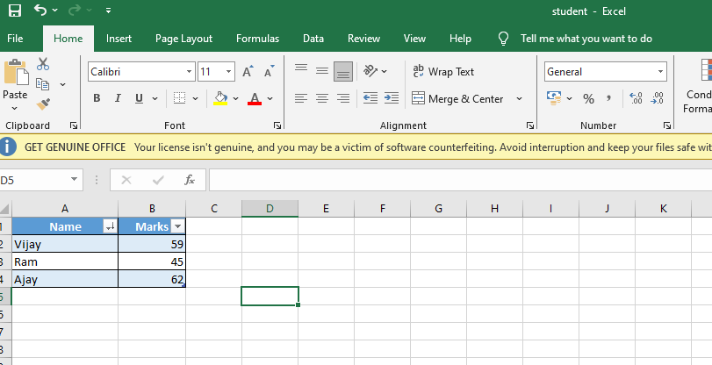

Step 2 : Step 2: Open UI path and create new project with appropriate name and choose language type VB.

Step 3 : Select Excel Process Scope from the activity window and drop into sequence

Step 4 : Select Do activity from the activity window and then select Use Excel File activity and give inputs as below. Insert Student.xlsx as excel input.

Step 5 : Again select Do activity from the activity box and insert Sort Table to sort the data . Use input values as shown below to read the data

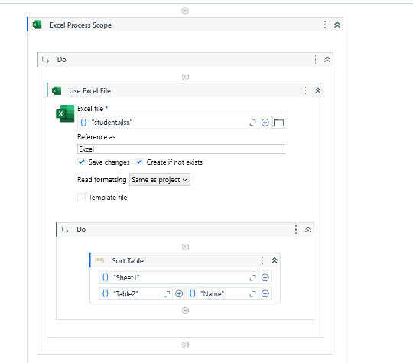

**o/p:**

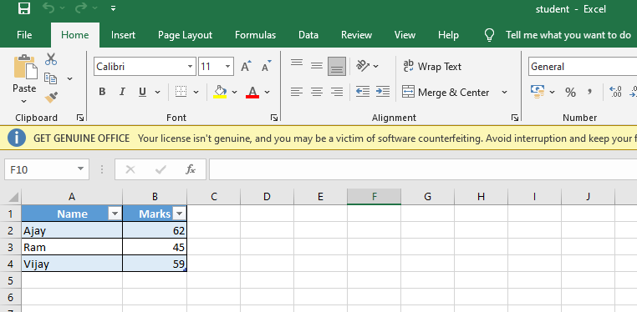

**4f: Create an automation to filter a table of an excel sheet**

Step 1 : Create an excel file Student.xlsx.

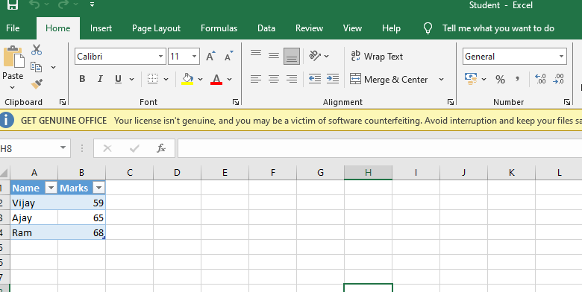

Step 2 : Step 2: Open UI path and create new project with appropriate name and choose language type VB.

Step 3 : Select Excel Process Scope from the activity window and drop into sequence

Step 4 : Select Do activity from the activity window and then select Use Excel File activity and give inputs as below. Insert Student.xlsx as excel input.

Step 5 : Again select Do activity from the activity box and insert Filter Table to filter the data . Use input values as shown below to read the data

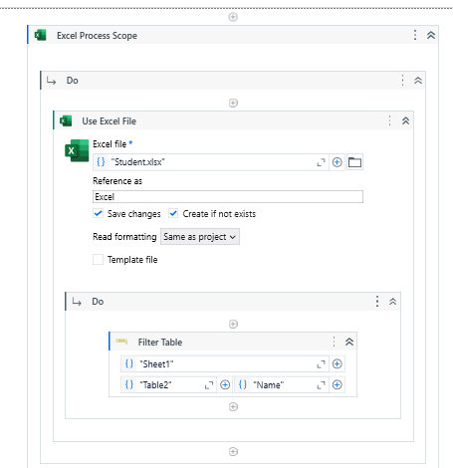

**o/p**

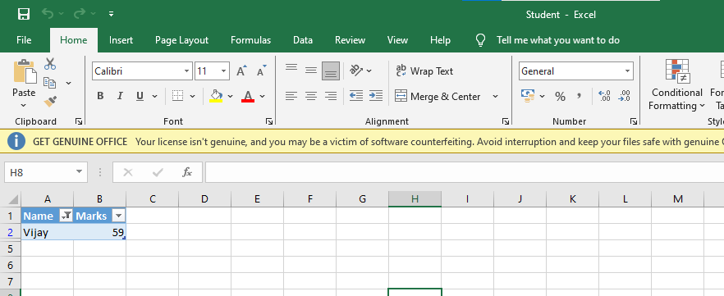

**Practical 5: Different controls in UiPath**

**a. Implement the attach window activity.**

Steps 1: Open UiPath Studio and click on Blank to start a fresh project. Give it a meaningful name. Like Pratical5A.

Steps 2: Open Main.xaml from Project tab. On the Designer panel, double click a Attached window activity from the Activities panel.

Steps 3: Open Notepad and click on Indicate window on screen from Attached window activity. And select blank notepad page.

Steps 4: Take another activity like Type Into activity and click on Indicate window on screen from type into activity. And type as per your requirement e.g. “welcome to sn College”.

Steps 5: It will show complete flow like below.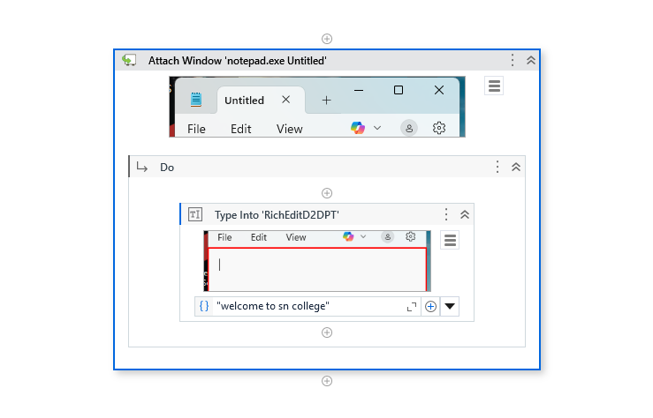

O/p:

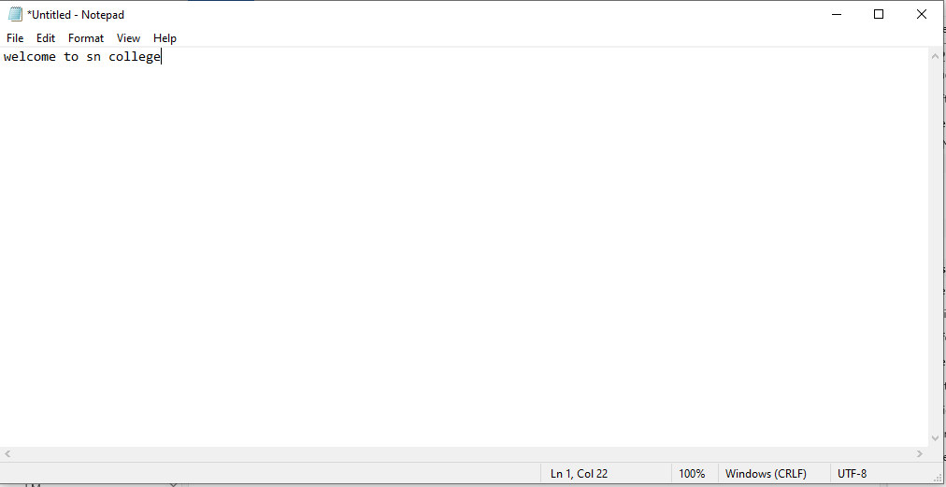

**b. Automate using Anchor Base.**

Steps 1: Open UiPath Studio and click on Blank to start a fresh project. Give it a meaningful name. Like Pratical5B.

Steps 2: Open Main.xaml from Project tab. On the Designer panel, double click **Anchor Base** activity from the Activities panel.

Steps 3: Select any label name from any form (Google form or any login form).

Steps 4: Select Anchor Position like top/bottom/left/right/auto.

Steps 5: Select **Type Into** activity from activity window. And select textbox which you want to fill.

Sample link:

<https://docs.google.com/forms/d/e/1FAIpQLSfBt4jcytSWD6_aH9j30SW8_qFF2U_4CjTB5ARUITJxqfstyg/viewform?usp=pp_url>

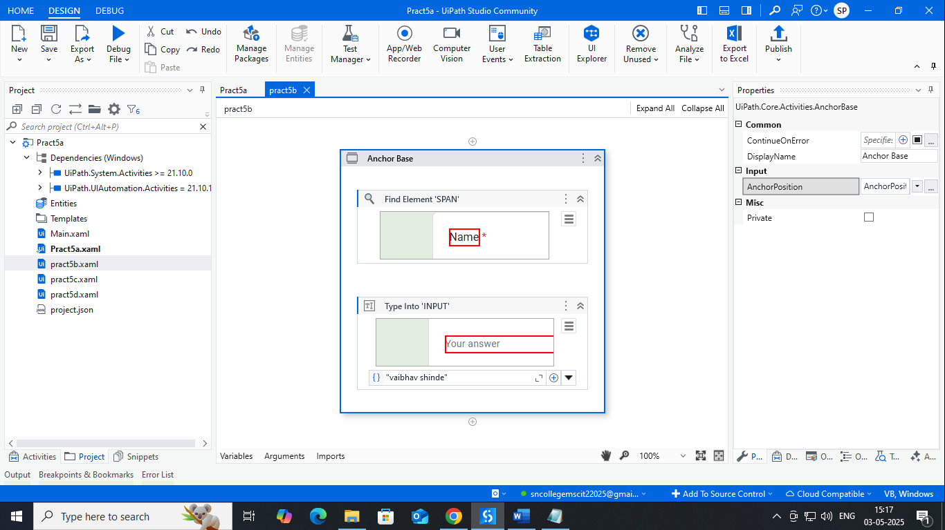

**O/P:**

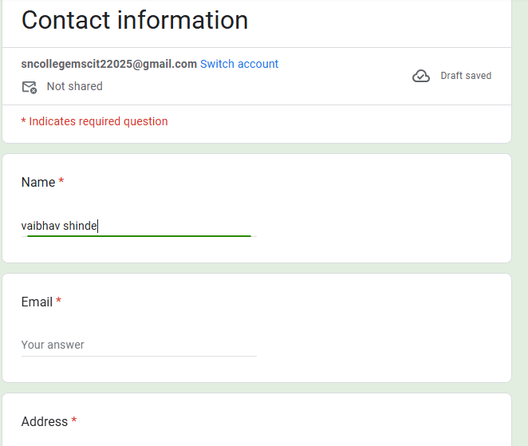

**c. Automate using Element Exists.**

Steps 1: Open UiPath Studio and click on Blank to start a fresh project. Give it a meaningful name. Like Pratical5B.

Steps 2: Open Main.xaml from Project tab. On the Designer panel, double click **Element Exists** activity from the Activities panel.

Steps 3: Click on Indicate window on screen and select **Google search** button from **google.com**.

Steps 4: Create one variable **nameexists** as **boolean**. And mapped in exists property of **Element Exists** activity**.**

Steps 5: Select **Else-if** activity from activity window. And give condition as below.

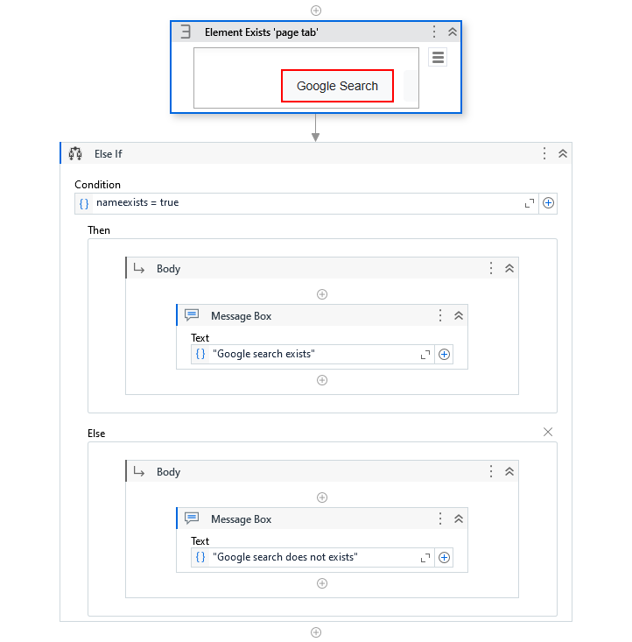

**O/p:**

|  |  |
| --- | --- |
| **For** [**https://www.google.com**](https://www.google.com) | **For https://www.google.com/imghp** |
|  |  |

**d. Automate using Find Children control.**

# **PRACTICAL NUMBER: 6B**

**B. Demonstrate the following events in UiPath:**

i) Element triggering event

1. Open UiPath Studio and click on Blank to start a fresh project. Give it a meaningful name. Like Pratical6b.
2. Open Main.xaml from Project tab. On the Designer panel, double click a flowchart activity from the Activities panel.
3. Create a sequence and set it as Start node.
4. Drag and drop a trigger scope activity and in triggers add click trigger – indicate an untitled notepad and specify the mouse button.
5. In actions section’s sequence add a type into activity - indicate an untitled notepad and add some text.

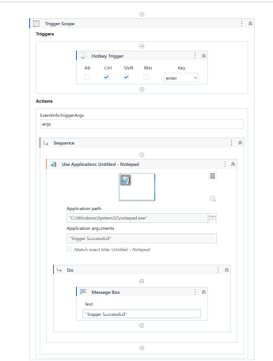

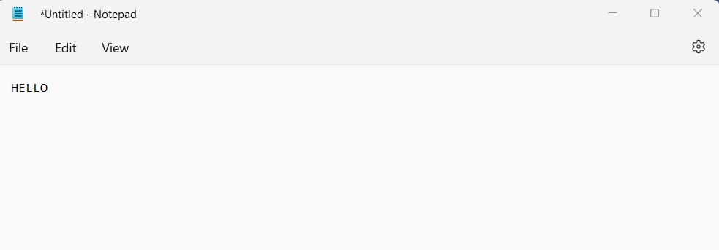

1. Image triggering event
   1. Create another sequence and set this as Start node.
   2. Drag and drop a trigger scope activity and in triggers section add click image trigger – indicate a region of image and specify mouse button.
   3. In action’s sequence section add a message box and enter some text to display.

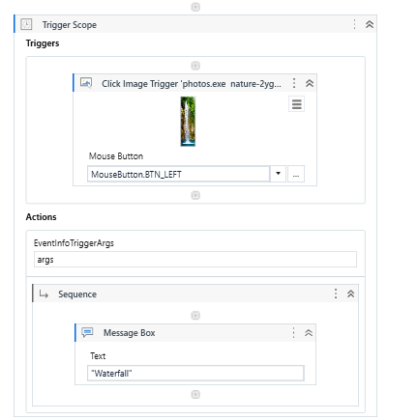

Output:

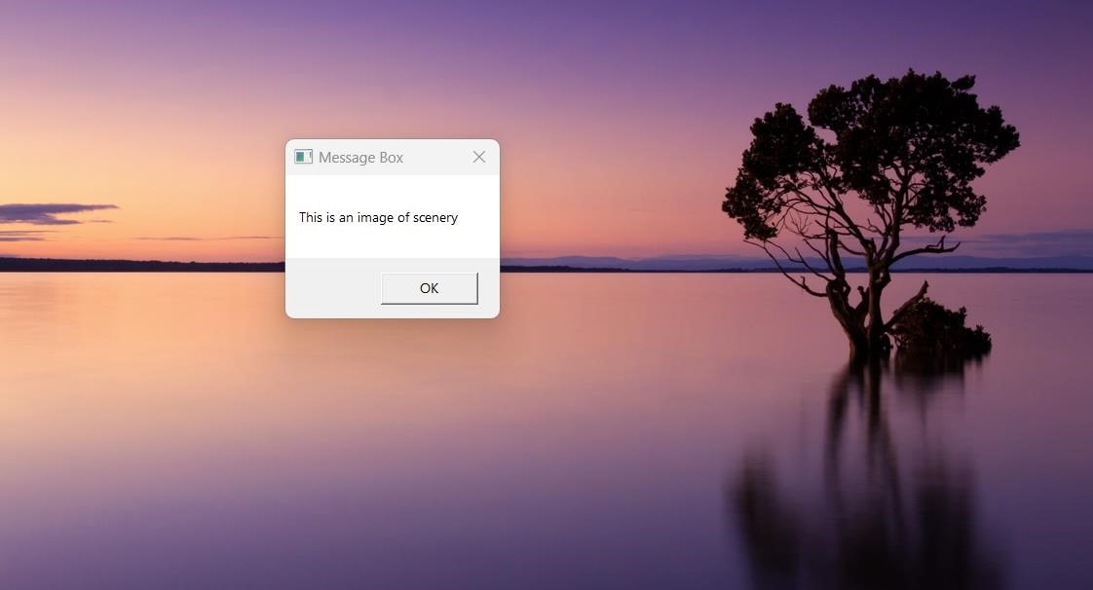

1. System Triggering Event.
   1. Create another sequence and set this as Start node.
   2. Drag and drop a trigger scope activity and in triggers section add system trigger – check both keyboard and mouse from its properties panel.
   3. In action’s sequence section add a Write Line activity and enter some text to display.

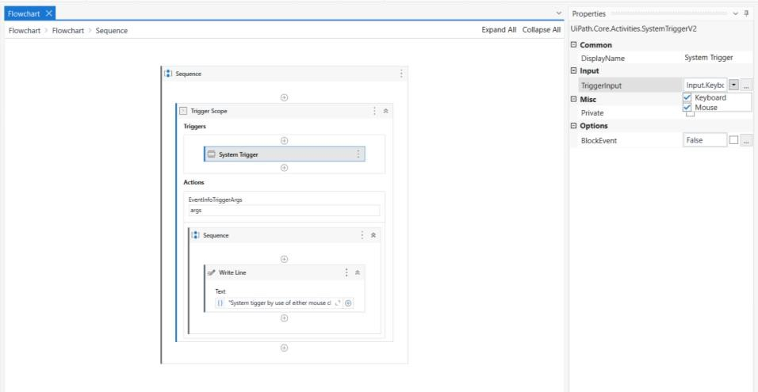

O/P:

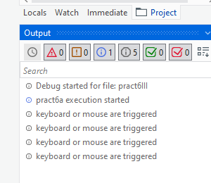

**Practical No 7**

**b. Automate the following screen scraping methods using UIPath**

i. Full Text

ii. Native

iii. OCR

1. Open UiPath Studio and click on Blank to start a fresh project. Give it a meaningful name. Like Pratical.
2. Open Main.xaml from Project tab. On the Designer panel, double click a flowchart activity from the Activities panel.
3. Click on Screen Scraping option from design tab and specify the region from which we need to extract the information.
4. Specify scraping methods as full text and click on finish.
5. Repeat step 3 and 4 by changing methods as Native and OCR.

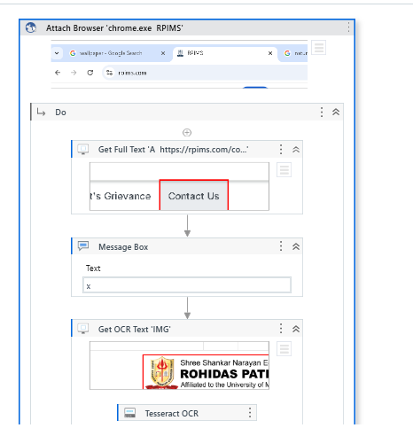

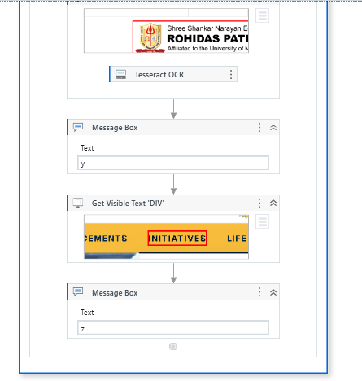

Output:

Native text:

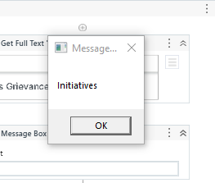

OCR text:

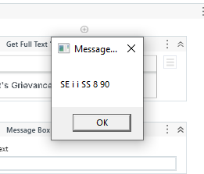

Full text:

